

**ME361: MANUFACTURING PROCESSES II**

GROUP NO.: 4

LAB DAY: THURSDAY

**VENDING MACHINE**

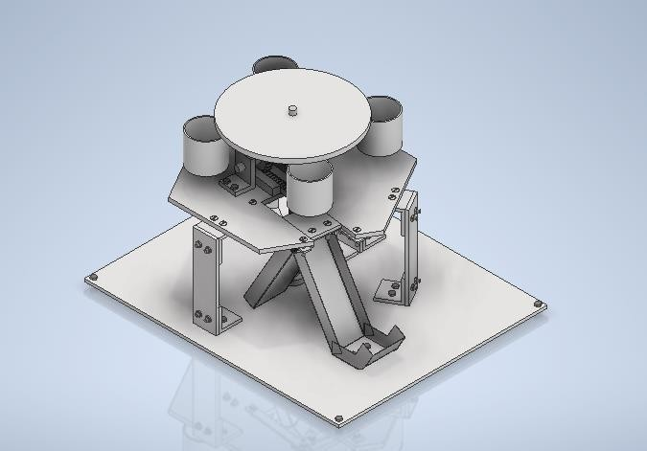

COURSE INSTRUCTOR: Dr. Sarvesh Mishra

Group Members

1. Alka (220100) 7. Prabhat Kumar Purbay (220731)
2. Arun Dwivedi (220196) 8. Prakhar Chhalotre (220737)
3. Ashish Kumar Gupta (220213) 9. Roy Shivam Ram Shreshtt (220877)
4. Anjali Kumari (220155) 10. Sujeet Kumar (221067)
5. Dharmendra Yadav (220335) 11. Yaman Manish Oza (221186)
6. Garima Mittal (220380) 12. Neeraj Swami (210543)

# OVERVIEW

We have designed a small-scale prototype of a bottle vending machine for the hot summers of Kanpur. The number of parts manufactured by us was around 30. The estimated price for the product, including the labor cost, is 24,306.75 Indian rupees. There are many things that we feel can be improved, such as the bottle-carrying capacity and the accuracy of the motors. The tolerance of the bottle-dropping mechanism should be increased to let the bottles fall easily. There can be some system that keeps the bottles cool.

# ACKNOWLEDGEMENT

We sincerely express our gratitude to our tutor **DR. Sarvesh Mishra** our laboratory in-charge, Mr. **G Shreenivasulu**, and our laboratory guide, **Mr. Rahul** for their valuable support and advice in this project. This wouldn’t have been possible without their technical and moral support.

We would like to express our gratitude toward all lab staff for their constant supervision and encouragement which helped us in the completion of the project.

Special thanks to our TAs, and for taking out time for us.

Overall, we thank our instructor in charge, **DR. Sarvesh Mishra** for providing us with this opportunity to learn, explore and make something valuable using different manufacturing processes.

# CONTENTS

**Page**

1. Assembly drawing 4
2. Design Calculations 5-8
3. Part List 9
4. Part drawings 10-33
   1. Baseplate Drawing 10
   2. Hexagonal Disk Drawing 11
   3. Circular-Assembly 12
   4. Main Shaft 13
   5. Shaft (for Bevel gear (20)) 14
   6. Shaft (for spur gear) 15
   7. Collar 16
   8. Bevel Gear (20) 17
   9. Bevel Gear (40) 18
   10. Spur Gear 19
   11. Rack 20
   12. Guider 21
   13. Slot-slider 22
   14. Bottle-collector 23
   15. Motor-support 24
   16. Motor-holder 25
   17. L-supports 26-29
   18. Railings 30-32
5. Cost Analysis 33

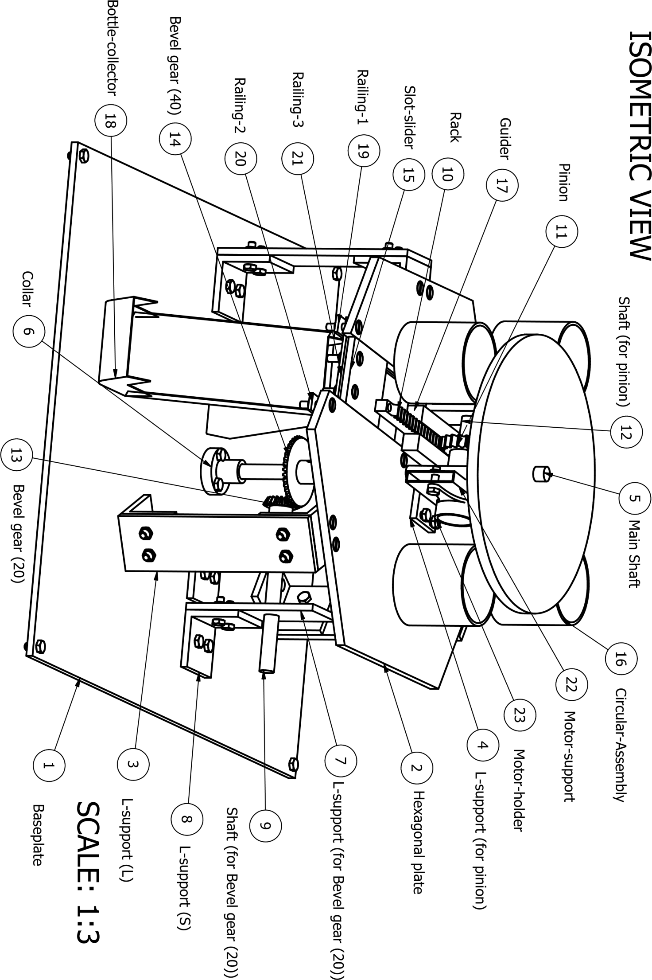

# DESIGN CALCULATIONS

* **CALCULATIONS FOR BEVEL GEARS**

|  |  |  |  |  |  |
| --- | --- | --- | --- | --- | --- |
|  | | Pinion | | Gear | |
| Shaft Angle, Σ | | 𝛴 = 90° | | 𝛴 = 90° | |
| Module, m | | 𝑚 = 1.5 𝑚𝑚 | | 𝑚 = 1.5 𝑚𝑚 | |
| Pressure angle, α | | 𝛼 = 20° | | 𝛼 = 20° | |
| Number of teeth, z | | 𝑧1 = 20 | | 𝑧2 = 40 | |
| Pitch diameter, d | | 𝑑1 = 𝑚 ∙ 𝑧1 = (1.5)(20) =  30 𝑚𝑚 | | 𝑑2 = 𝑚 ∙ 𝑧2 = (1.5)(40)  = 60 𝑚𝑚 | |
| Pitch cone angle, 𝜹𝟏,  𝜹𝟐 | | 𝑠𝑖𝑛 𝛴  𝛿1 = 𝑡𝑎𝑛−1 (𝑧1 + 𝑐𝑜𝑠 𝛴)  𝑧2  = tan−1(2)  = 63.4350° | | 𝛿2 = 𝛴 − 𝛿1 = 90°  − 63.435°  = 26.5650° | |
| Cone distance, 𝑅e | | 𝑑2 60  𝑅𝑒 = =  2 𝑠𝑖𝑛 𝛿2 2(0.4472)  = 67.0841 𝑚𝑚 | | 𝑑2  𝑅𝑒 =  2 𝑠𝑖𝑛 𝛿2  =  = 67.0841 𝑚𝑚 | |
| Face width, b | | 𝑅𝑒  𝑏 = 6.7 𝑚𝑚 | | 𝑅𝑒  𝑏 = 6.7 𝑚𝑚 | |
| Addendum, 𝒉𝒂 | | ℎ𝑎 = 𝑚 = 1.5 𝑚𝑚 | | ℎ𝑎 = 𝑚 = 1.5 𝑚𝑚 | |
| Dedendum, 𝒉𝒇 | | ℎ𝑓 = 1.25𝑚 = 1.875 𝑚𝑚 | | ℎ𝑓 = 1.25 = 1.875 𝑚𝑚 | |
| Dedendum angle, 𝜽𝒇 | | ℎ  𝜃𝑓 = 𝑡𝑎𝑛−1 ( 𝑓 )  𝑅𝑒  = 𝑡𝑎𝑛−1(0.0279)  = 1.5981° | | 𝜃𝑓  ℎ  = 𝑡𝑎𝑛−1 ( 𝑓 )  𝑅𝑒  = 𝑡𝑎𝑛−1(0.0279)  = 1.5981° | |
| Addendum angle, 𝜽𝒇 | | ℎ  𝜃𝑎 = 𝑡𝑎𝑛−1 ( 𝑎)  𝑅𝑒  = 𝑡𝑎𝑛−1(0.0224)  = 1.2832° | | ℎ  𝜃𝑎 = 𝑡𝑎𝑛−1 ( 𝑎)  𝑅𝑒  = 𝑡𝑎𝑛−1(0.0224)  = 1.2832° | |
| Outer cone angle,  𝜹𝒂𝟏 , 𝜹𝒂𝟐 | | 𝛿𝑎1 = 𝛿1 + 𝜃𝑎  = 63.4350°  + 1.2832°  = 64.7182° | | 𝛿𝑎2 = 𝛿2 + 𝜃𝑎  = 26.5650°  + 1.2832°  = 27.8482° | |
| Root cone angle, 𝜹𝒇𝟏,  𝜹𝒇𝟐 | | 𝛿𝑓1 = 𝛿1 − 𝜃𝑓  = 63.4350°  − 1.5981°  = 61.8369° | | 𝛿𝑓2 = 𝛿2 − 𝜃𝑓  = 26.5650°  − 1.5981°  = 24.9669° | |
| Outside diameter, ⅆ𝒂𝟏, ⅆ𝒂𝟐 | | 𝑑𝑎1 = 𝑑1 + 2ℎ𝑎 𝑐𝑜𝑠 𝛿1  = 30  + 2(1.5)(0.4472)  = 31.3416 𝑚𝑚 | | 𝑑𝑎2 = 𝑑2 + 2ℎ𝑎 𝑐𝑜𝑠 𝛿2  = 60  + 2(1.875)(0.8944)  = 63.3540 𝑚𝑚 | |
| Pitch apex to crown,  𝑿𝟏, 𝑿𝟐 | | 𝑋1 = 𝑅𝑒 𝑐𝑜𝑠 𝛿1 − ℎ𝑎 𝑠𝑖𝑛 𝛿1  = 67.0841(0.4472)  − 1.5(0.8944) = 28.6391 𝑚𝑚 | | 𝑋2  = 𝑅𝑒 𝑐𝑜𝑠 𝛿2 − ℎ𝑎 𝑠𝑖𝑛 𝛿2  = 67.0841(0.8944)  − 1.5(0.4472)  = 59.3292 𝑚𝑚 | |
| Axial face width, 𝑿𝒃𝟏,  𝑿𝒃𝟐 | | 𝑏 𝑐𝑜𝑠 𝛿𝑎1 6.7(0.4271)  𝑋𝑏1 = 𝑐𝑜𝑠 𝜃𝑎 =  = 2.8624 𝑚𝑚 | | 𝑏 𝑐𝑜𝑠 𝛿𝑎2  𝑋𝑏2 = 𝑐𝑜𝑠 𝜃𝑎  6.  =  = 5.9259 𝑚𝑚 | |
| Inner outside diameter, ⅆ𝒊𝟏, ⅆ𝒊𝟐 | | 2𝑏𝑠𝑖𝑛𝛿𝑎1  𝑑𝑖1 = 𝑑𝑎1 − 𝑐𝑜𝑠 𝜃𝑎  = 31.3416  −  = 19.2217 𝑚𝑚 | | 2𝑏𝑠𝑖𝑛𝛿𝑎2  𝑑𝑖2 = 𝑑𝑎2 − 𝑐𝑜𝑠 𝜃𝑎  = 63.3540  −  = 57.0930 𝑚𝑚 | |
| Depth of cut | | 2.157 ∙ 𝑚 = 2.157(1.5)  = 3.2355 𝑚𝑚 | | 2.157 ∙ 𝑚 = 2.157(1.5)  = 3.2355 𝑚𝑚 | |

* **CALCULATIONS FOR RACK AND PINION**

|  |  |
| --- | --- |
| *Spur Gear-Number of teeth,* 𝑁1 | 𝑁1 = 20 |
| *Rack -Number of teeth,* 𝑁2 | 𝑁2 = 18 |
| *Module,* 𝑀 | 𝑀 = 2 𝑚𝑚 |
| *Pressure angle,* 𝛼 | 𝛼 = 20° |
| *Pitch of rack,* 𝑝 | 𝑝 = 𝜋𝑀 = 6.2832 𝑚𝑚 |
| *Tooth depth, h* | ℎ = 2.25𝑀 = 4.5 𝑚𝑚 |
| *Addendum,* ℎ𝑎 | ℎ𝑎 = 𝑀 = 2 𝑚𝑚 |
| *Dedendum,* ℎ𝑓 | ℎ𝑓 = 1.25𝑀 = 2.5 𝑚𝑚 |
| *Dedendum fillet radius,* 𝑅 | 𝑅 = 0.38𝑀 = 0.76 𝑚𝑚 |
| *Outer diameter,* 𝑂𝐷 | 𝑂𝐷 = 𝑀(𝑁1 + 2) = 44 𝑚𝑚 |
| *Pitch diameter,* 𝑑 | 𝑑 = 𝑀𝑁1 = 40 𝑚𝑚 |
| *Length of rack,* 𝐿 | 𝐿 = 127.101 𝑚𝑚 |
| *Depth of cut* | 2.157𝑀 = 4.314 𝑚𝑚 |
| *Indexing* | 40 40  = = 2  𝑁1 20 |

* **TORQUE CALCULATIONS**

|  |  |
| --- | --- |
| Moment of Inertia of (main shaft) + (circular assembly) + (bottles) | 0.105 kg.m2 |
| Angular velocity of (main shaft) + (circular assembly) + (bottles) | 15 rpm |
| Final Angular momentum of (main shaft) + (circular assembly) + (bottles) | 0.165 kg.m2/s |
| Moment of Inertia of (shaft attached to the motor) | 0.0242 kg.m2 |
| Angular velocity of (shaft attached to the motor) | 30 rpm |
| Final Angular momentum of (shaft attached to the motor) | 0.076 kg.m2/s |
| Time of Acceleration | 2s |
| Factor of Safety | 3 |
| Torque required | 0.315N.m<1N.m |

**PARTS LIST:**

|  |  |  |  |  |
| --- | --- | --- | --- | --- |
| **Part Name** | **Quantity** | **Material** | **Manufactured/Bought** | **Machining processes** |
| *Baseplate* | 1 | Mild Steel | Manufactured | Cutting, Drilling, |
| *Hexagonal disk* | 1 | Mild Steel | Manufactured | Cutting, Drilling, Milling |
| *L-support (L)* | 3 | Mild Steel | Manufactured | Cutting, Drilling |
| *L-support (for pinion)* | 2 | Mild Steel | Manufactured | Cutting, Drilling |
| *Main Shaft* | 1 | Mild Steel | Manufactured | Cutting |
| *Collar* | 1 | Mild Steel | Manufactured | Cutting, Drilling |
| *L-support (for Bevel Gear (20))* | 2 | Mild Steel | Manufactured | Cutting, Drilling |
| *L-support (S)* | 8 | Mild Steel | Manufactured | Cutting, Drilling |
| *Shaft (for Bevel Gear*  *(20))* | 1 | Mild Steel | Manufactured | Cutting, Drilling |
| *Rack* | 1 | Mild Steel | Manufactured | Cutting, Drilling, Turning, Milling |
| *Pinion* | 1 | Mild Steel | Manufactured | Cutting, Drilling, Turning, Milling |
| *Shaft (for pinion)* | 1 | Mild Steel | Manufactured | Cutting, Drilling |
| *Bevel Gear (20)* | 1 | Mild Steel | Manufactured | Cutting, Drilling, Turning, Milling |
| *Bevel Gear (40)* | 1 | Mild Steel | Manufactured | Cutting, Drilling, Turning, Milling |
| *Slot-Slider* | 1 | Mild Steel | Manufactured | Cutting, Drilling |
| *Circular-Assembly* | 1 | Mild Steel | Manufactured | Cutting, Drilling |
| *Guider* | 2 | Mild Steel | Manufactured | Cutting, Drilling |
| *Bottle-Collector* | 1 | GI Sheet | Manufactured | Cutting |
| *Railing-1* | 1 | Mild Steel | Manufactured | Cutting, Drilling |
| *Railing-2* | 1 | Mild Steel | Manufactured | Cutting, Drilling |
| *Railing-3* | 1 | Mild Steel | Manufactured | Cutting, Drilling |
| *Motor- support* | 1 | Mild Steel | Manufactured | Cutting, Drilling |
| *Motor holder* | 1 | Polylactic acid (PLA) | Manufactured | 3D Printing |

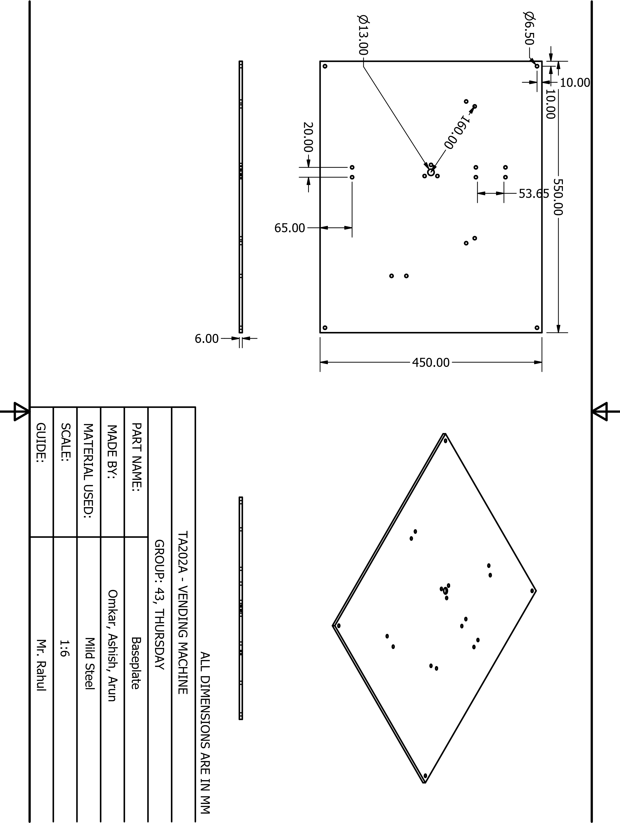

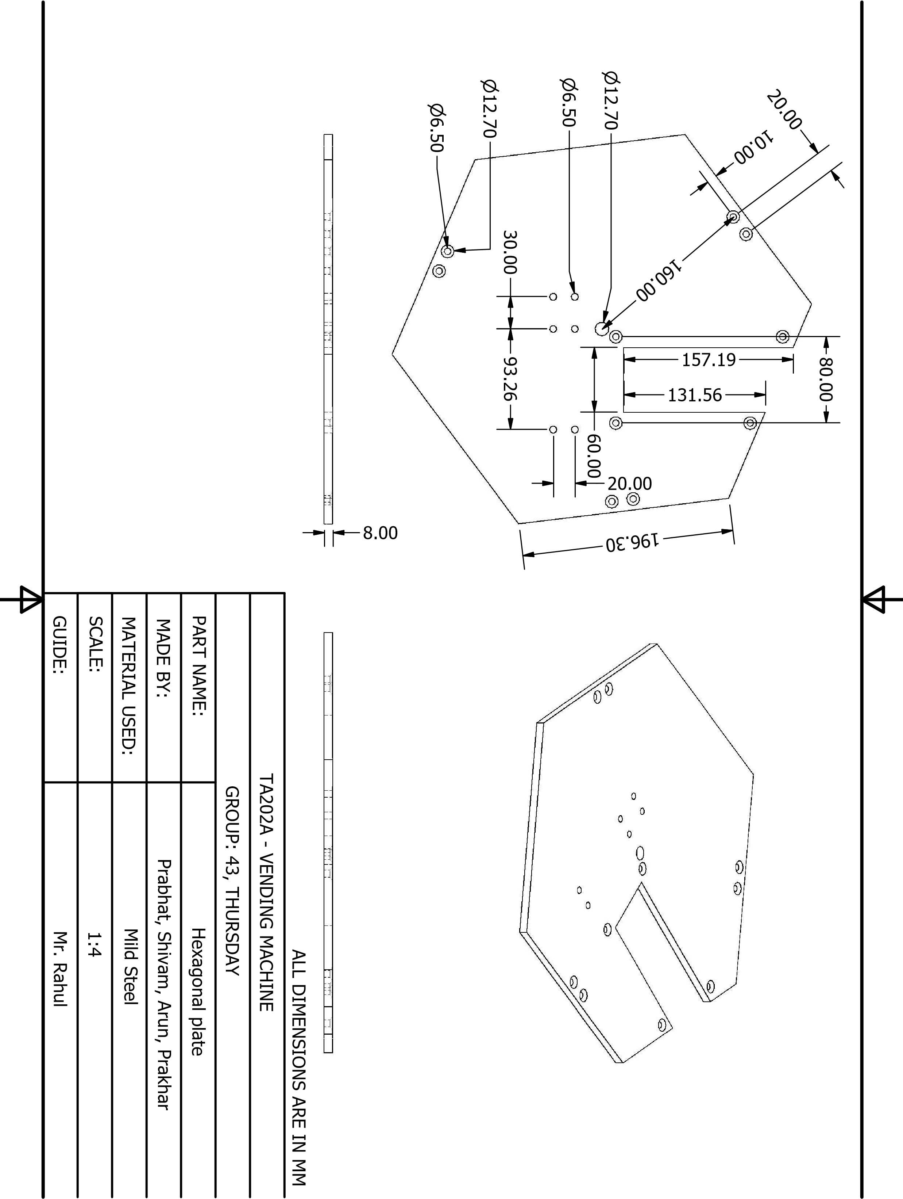

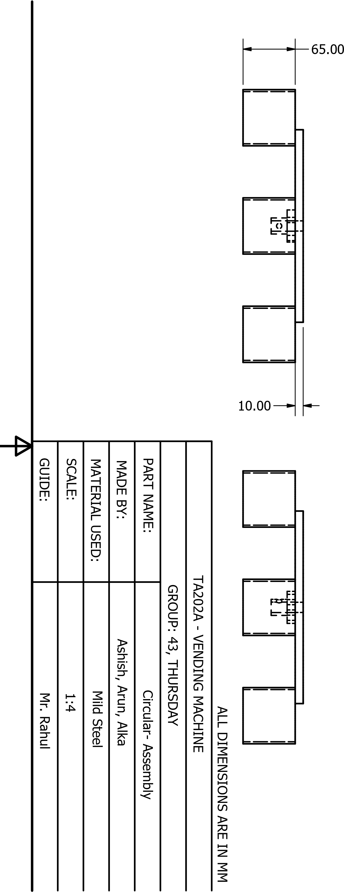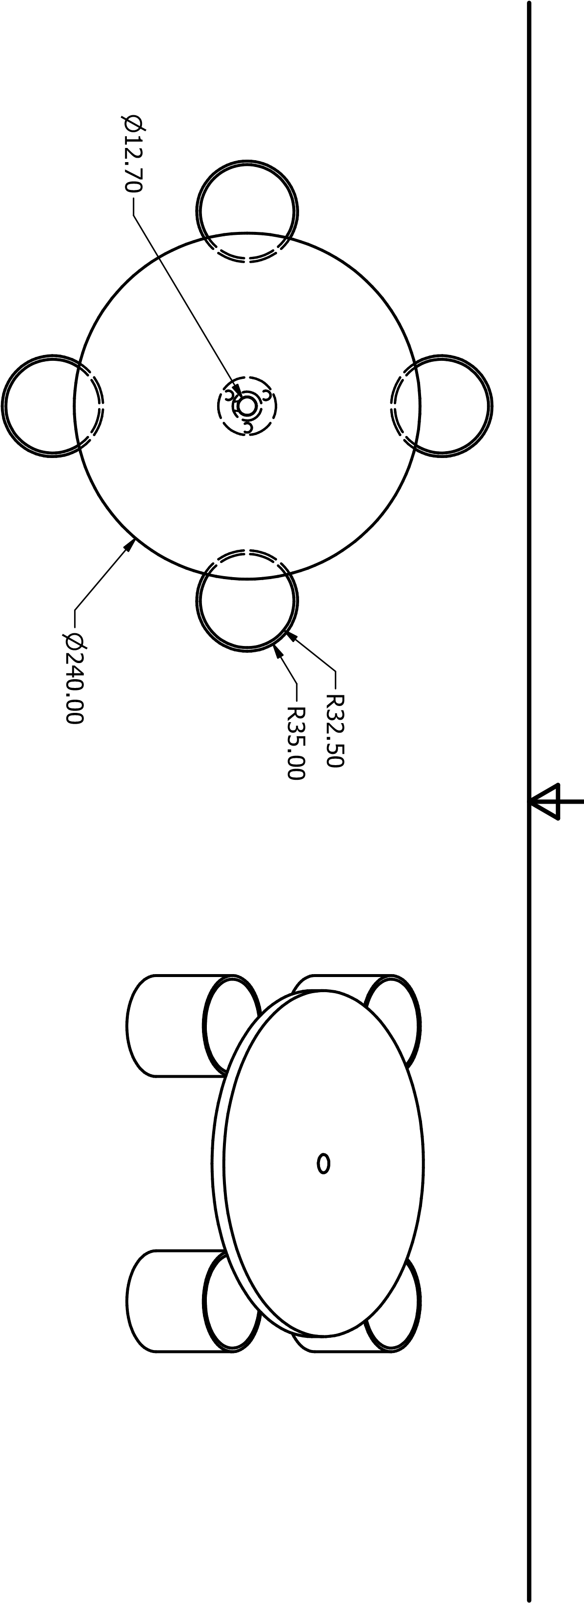

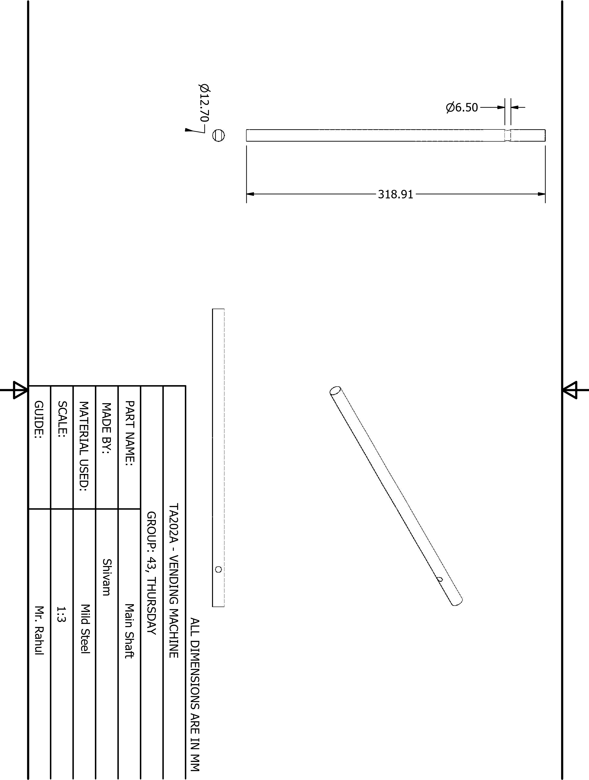

TA202A - VENDING MACHINE

PART NAME:

MADE BY:

MATERIAL USED:

SCALE:

GUIDE:

Mr. Rahul

GROUP: 43, THURSDAY

Shaft (for Bevel gear (20))

Shivam

Mild Steel

1:2

ALL DIMENSIONS ARE IN MM

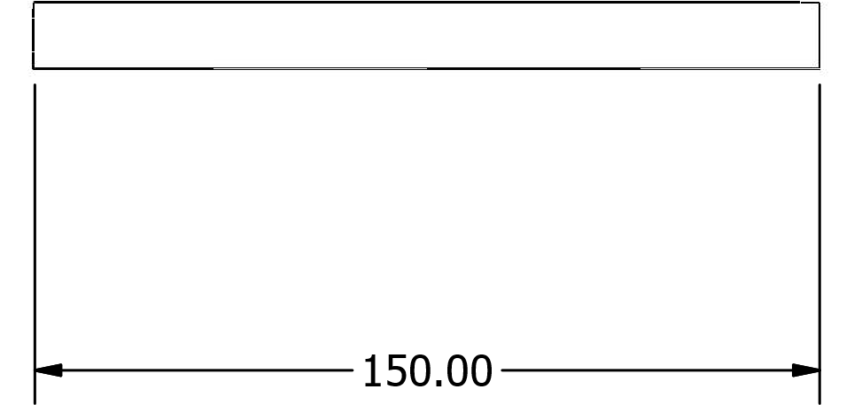

n

12.70

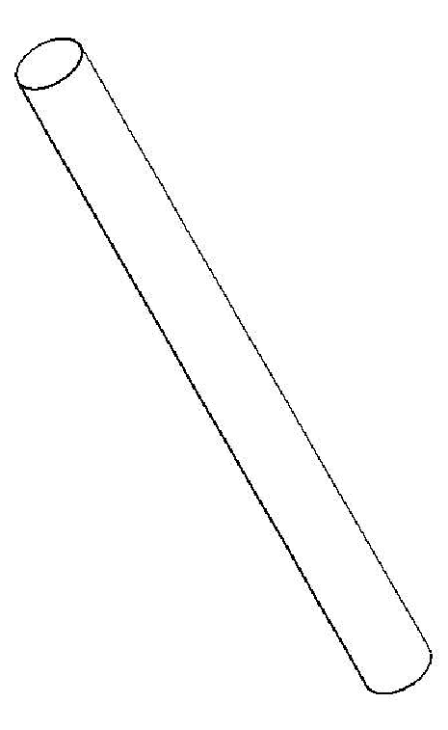

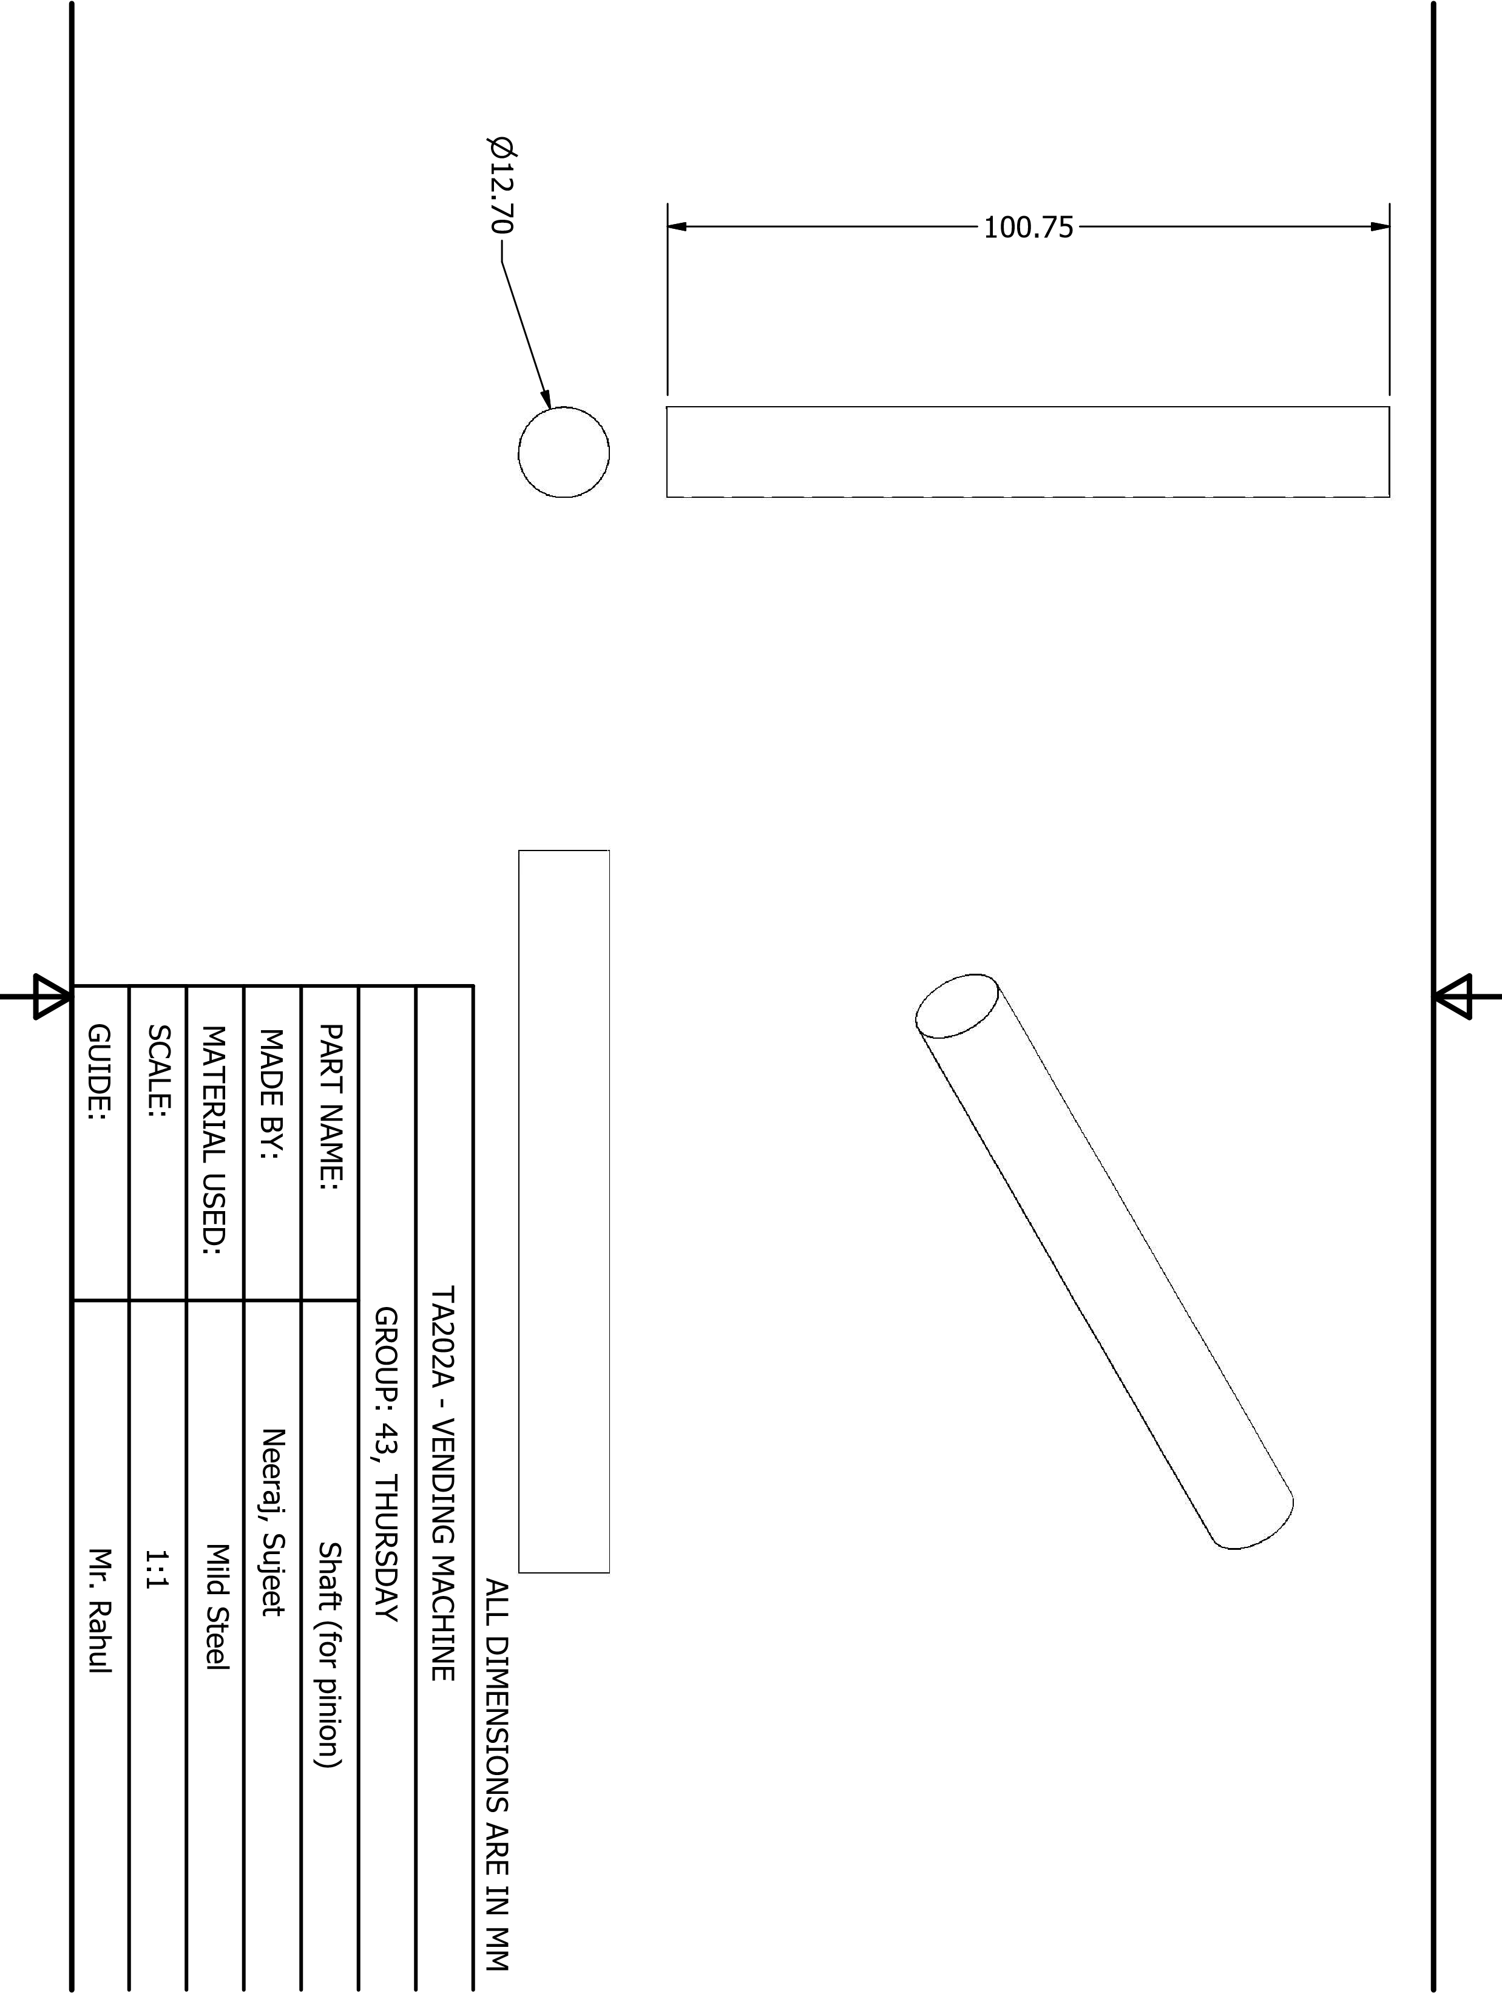

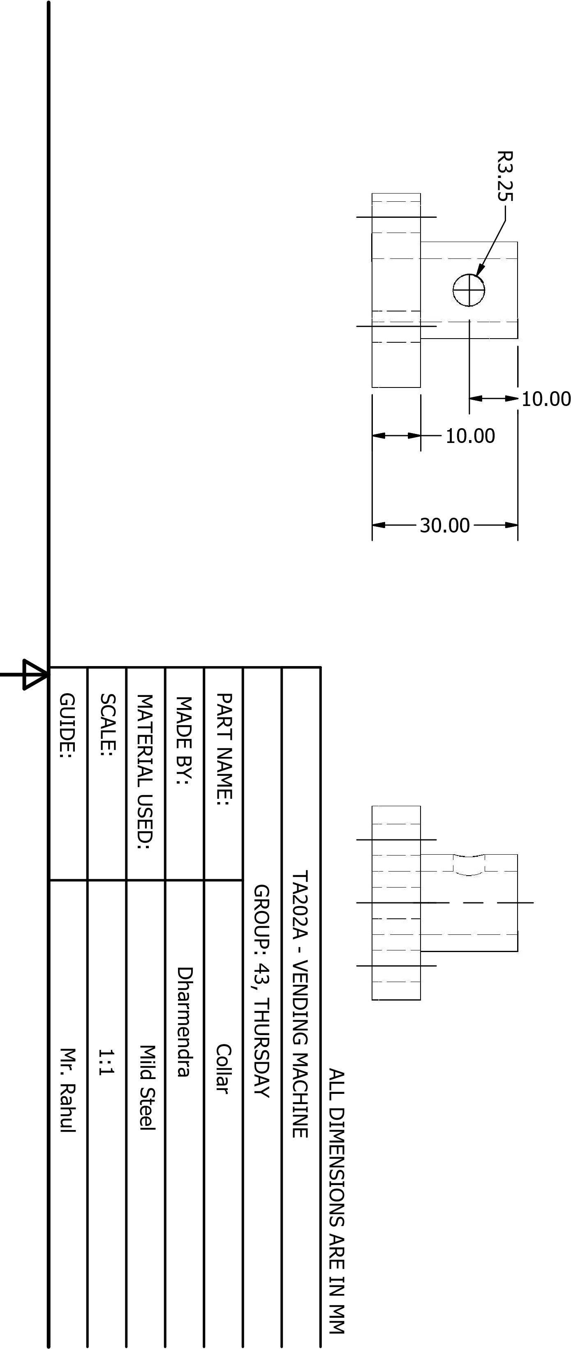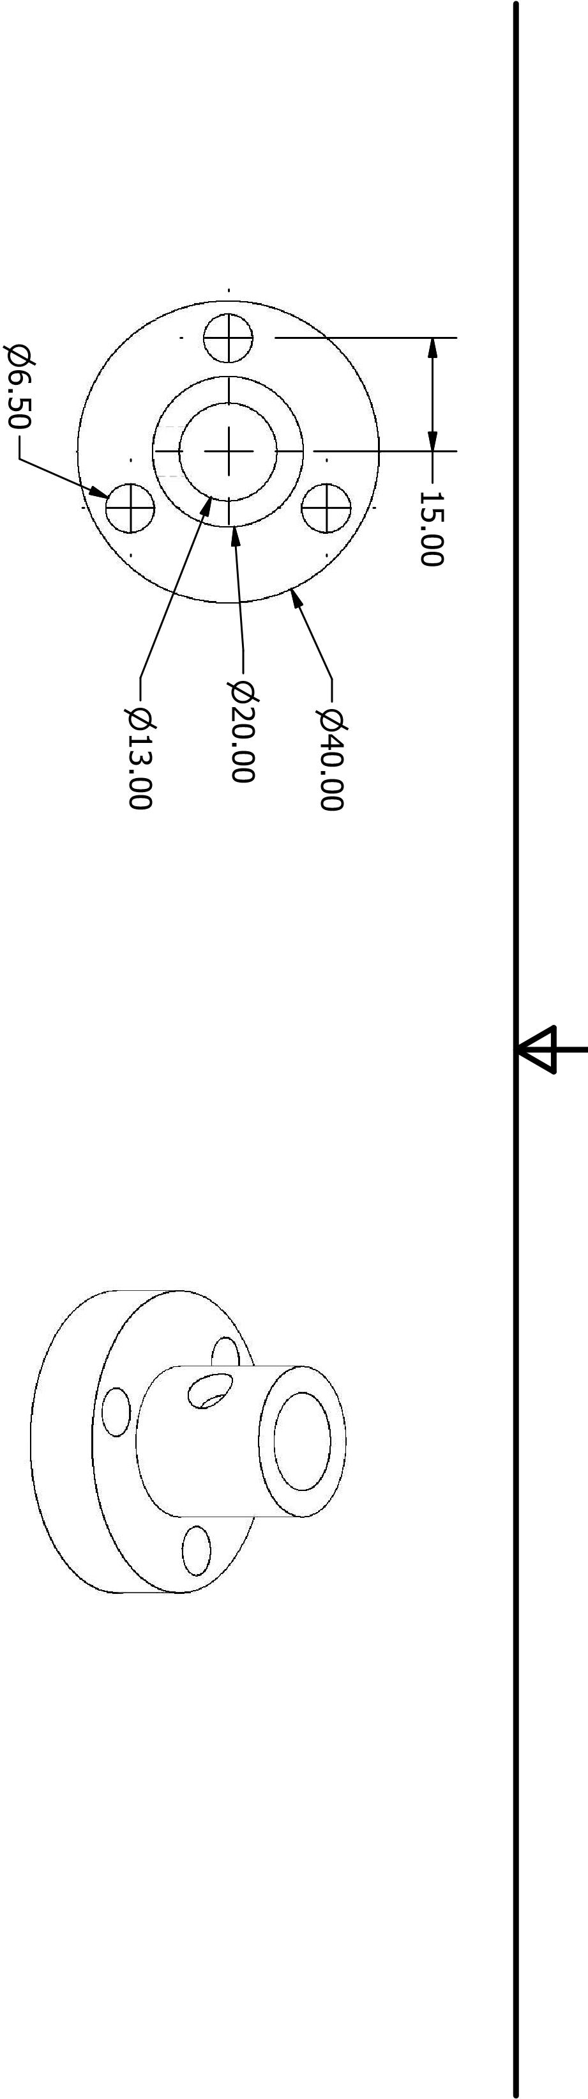

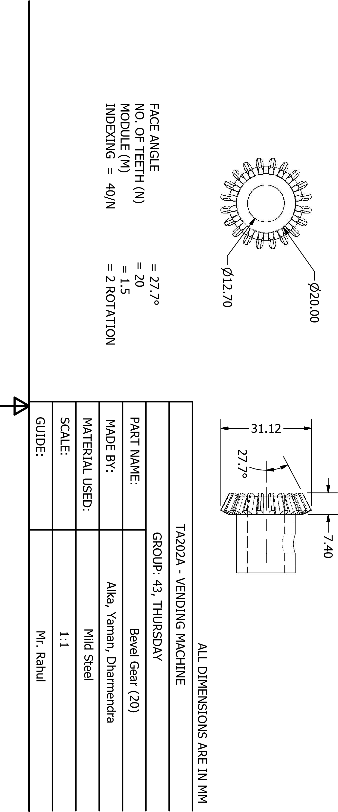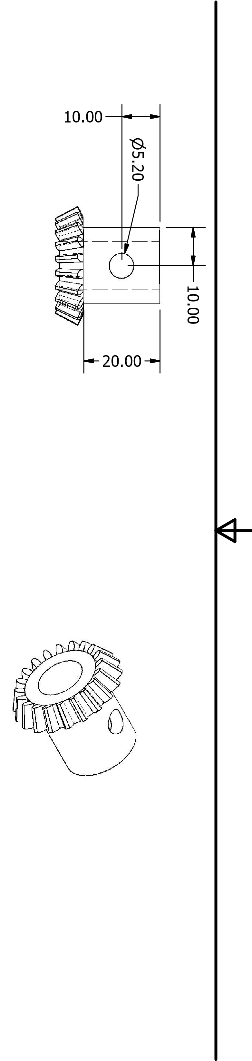

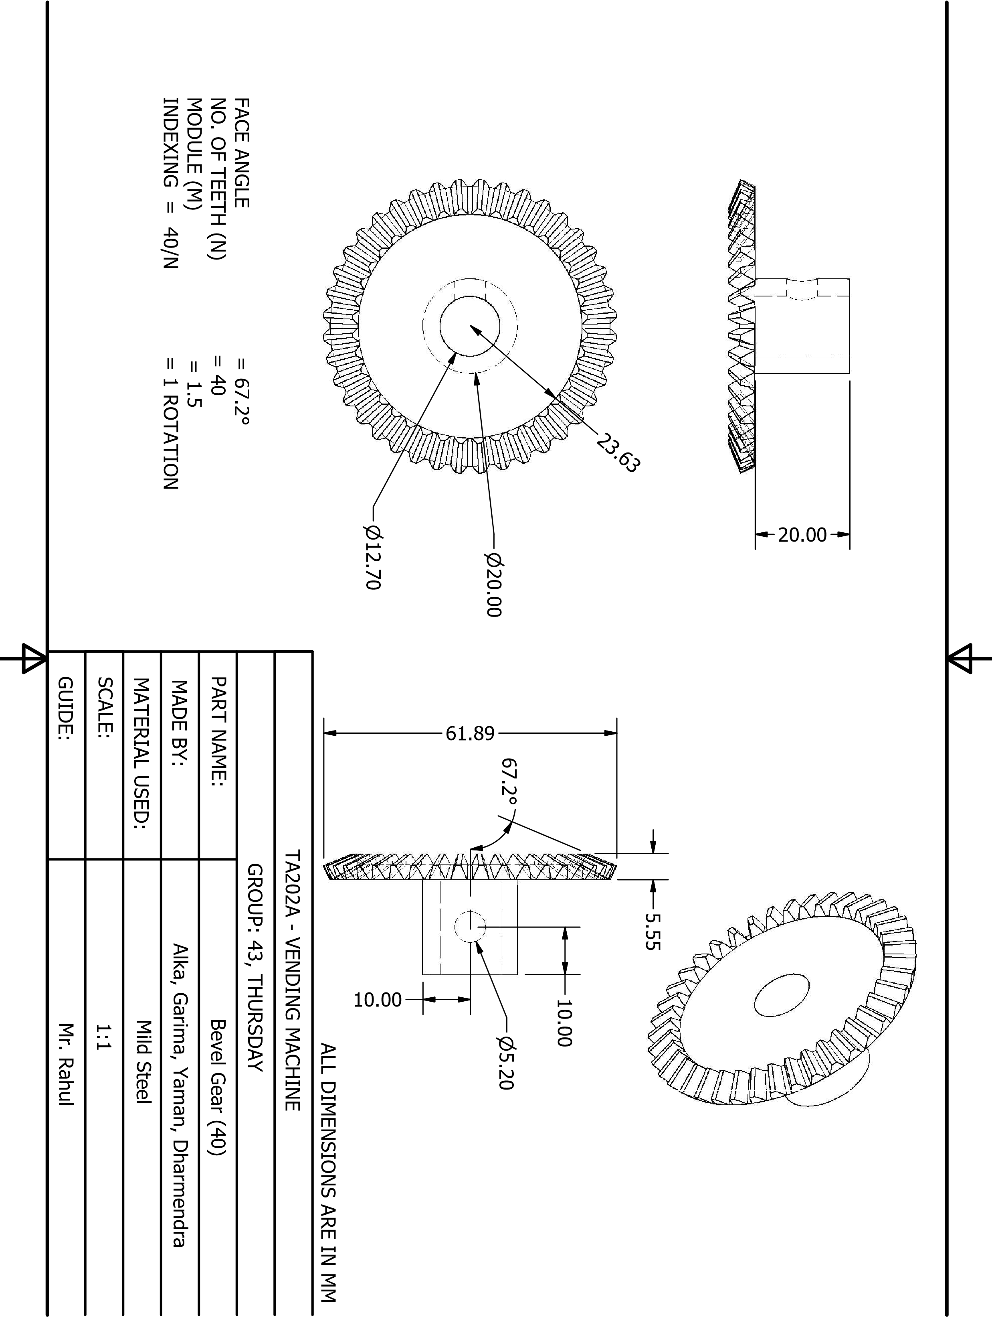

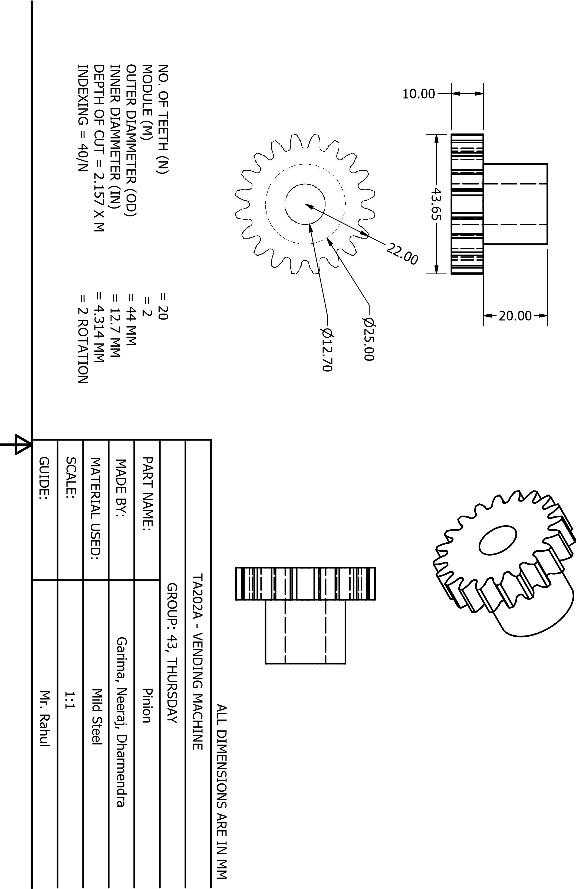

TA202A - VENDING MACHINE

PART NAME:

MADE BY:

MATERIAL USED:

SCALE:

GUIDE:

Mr. Rahul

GROUP: 43, THURSDAY

Rack

Garima, Neeraj

Mild Steel

1:1.5

ALL DIMENSIONS ARE IN MM

MODULE (M) = 2

TOOTH DEPTH = 2.25 X M = 4.50 MM

PITCH OF RACK =

π

X M

= 6.28 MM

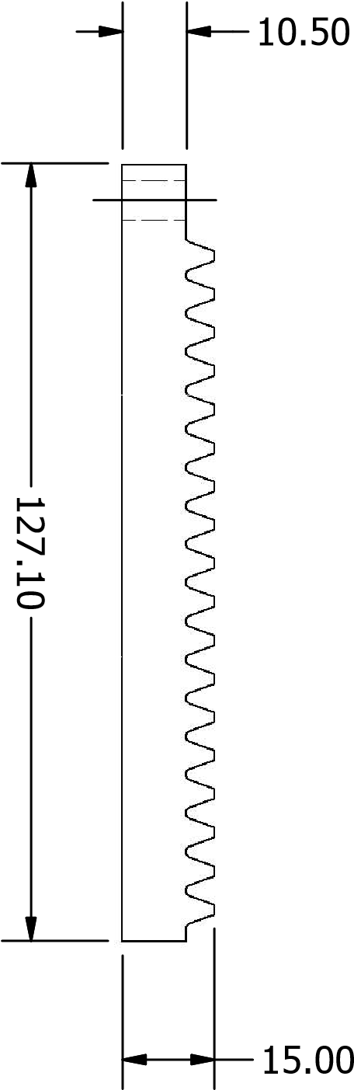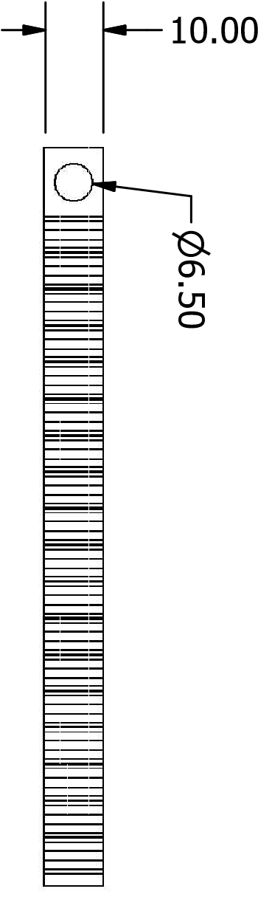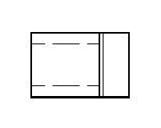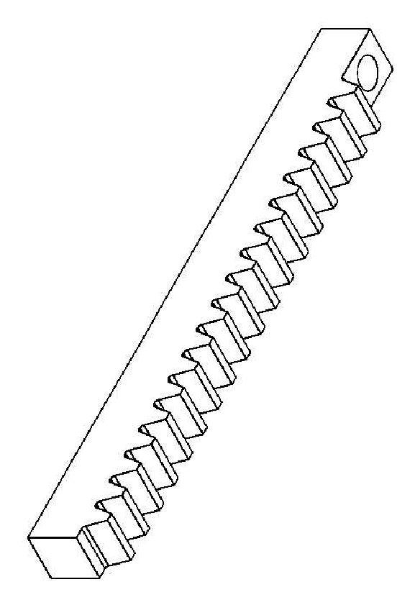

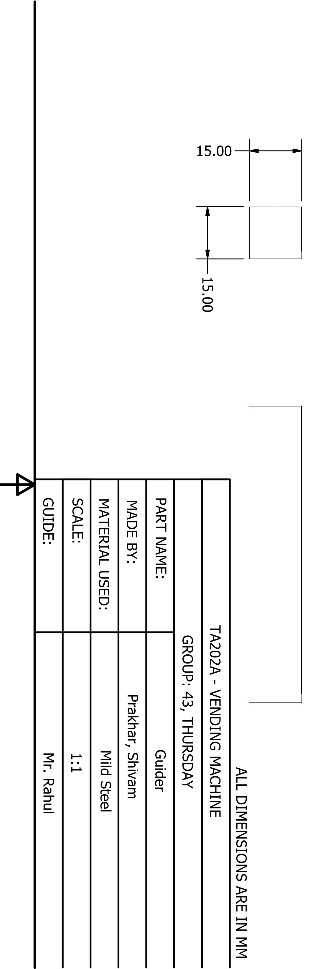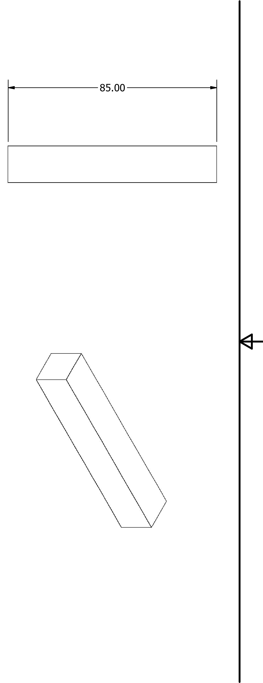

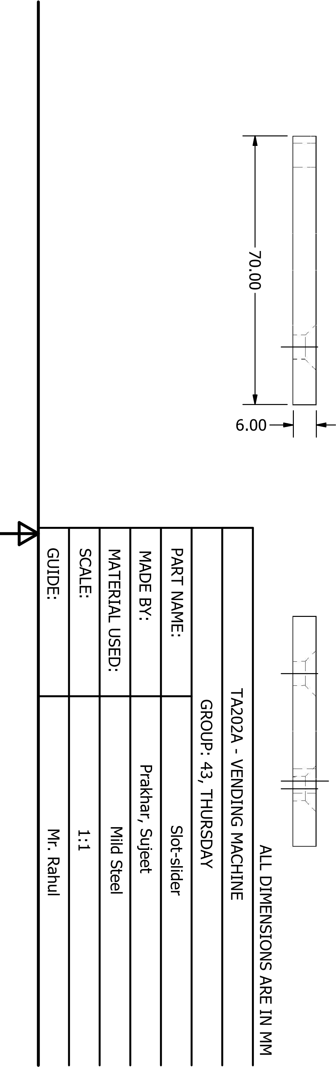

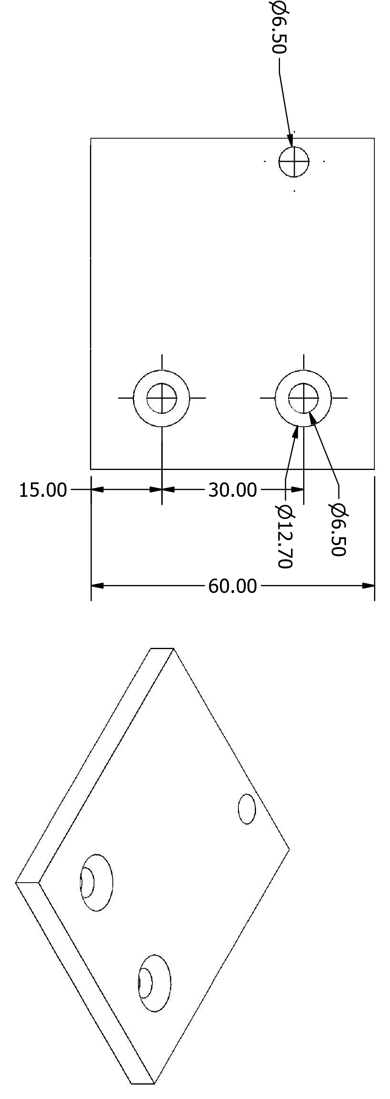

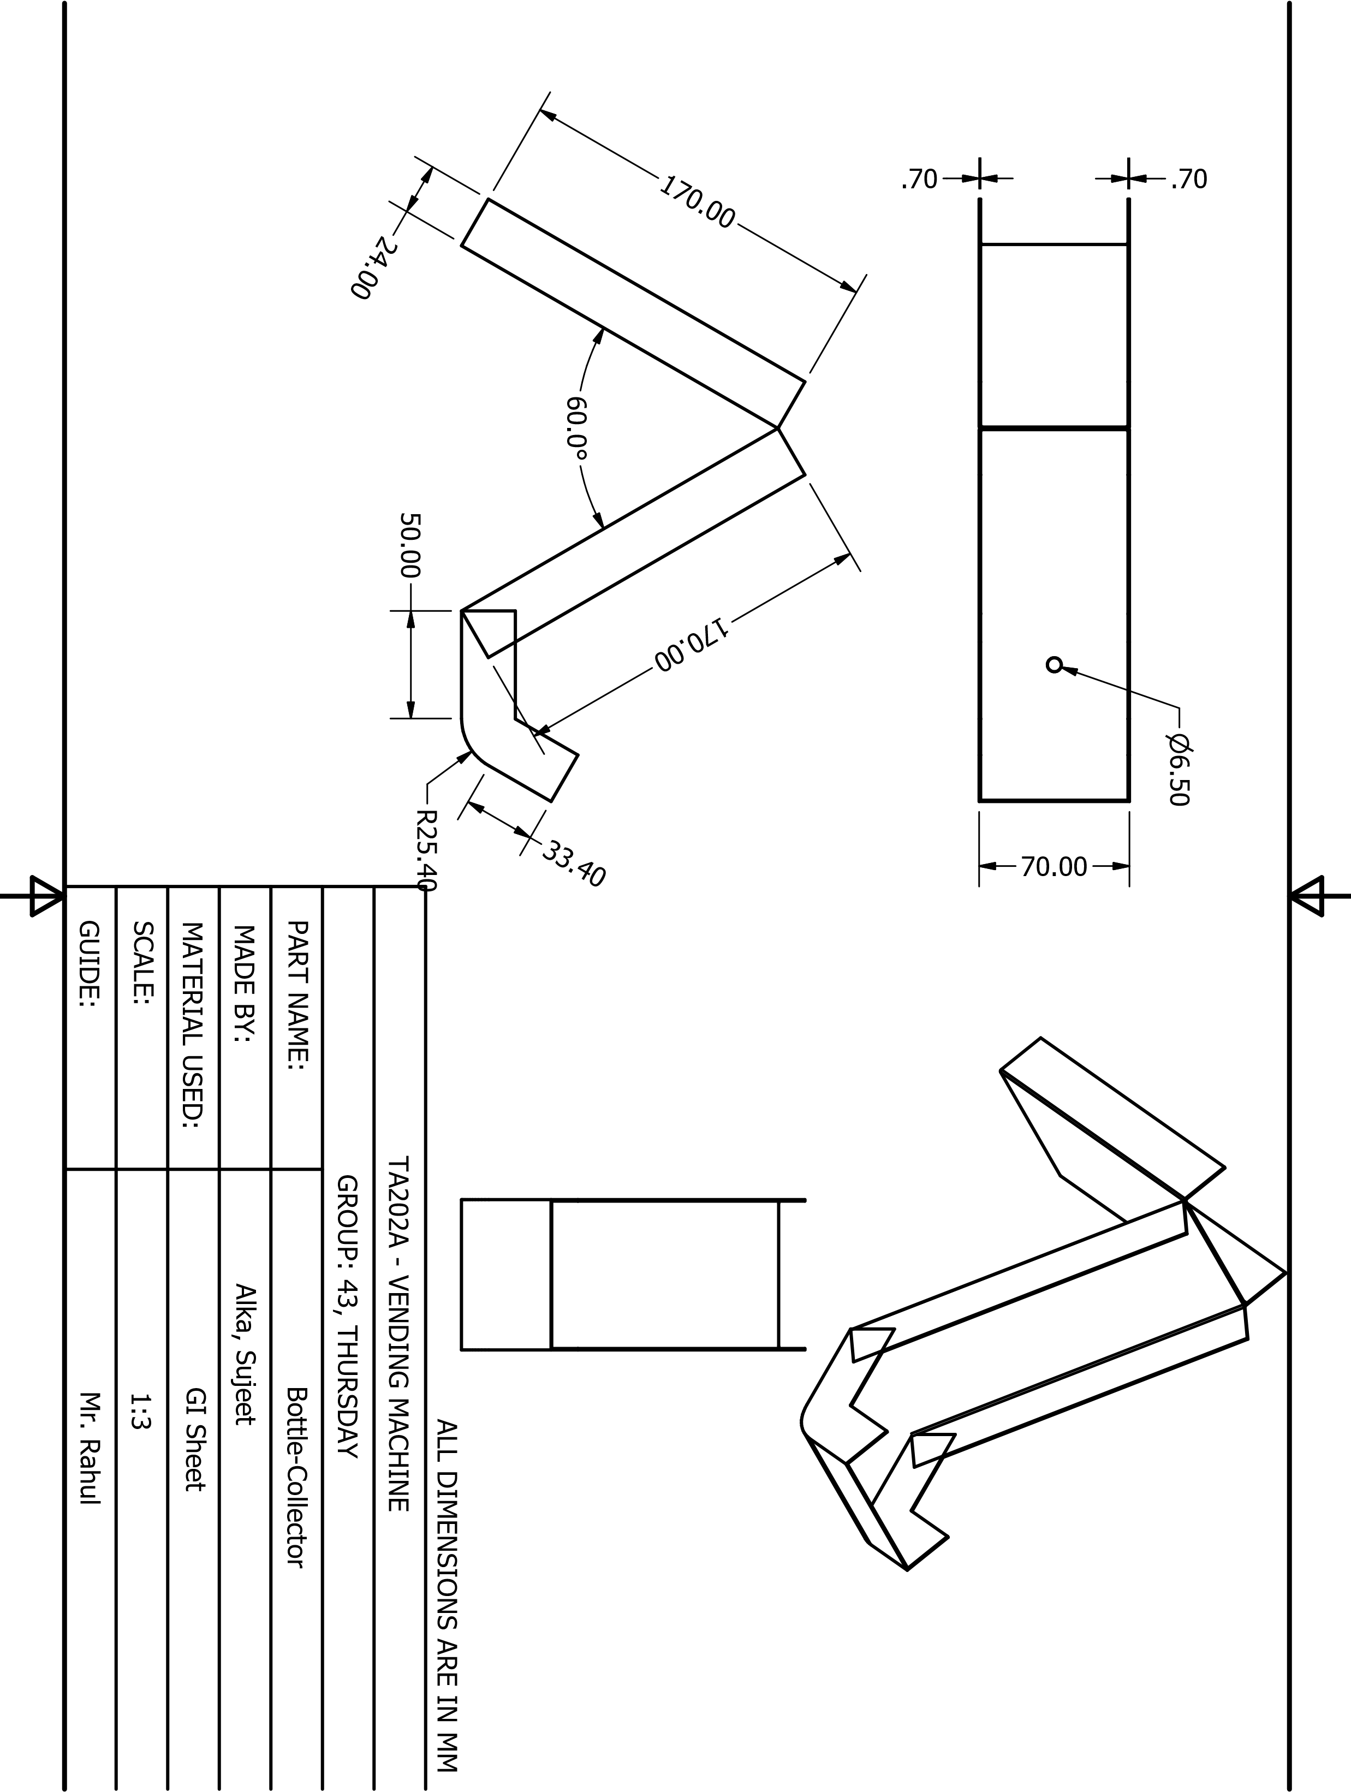

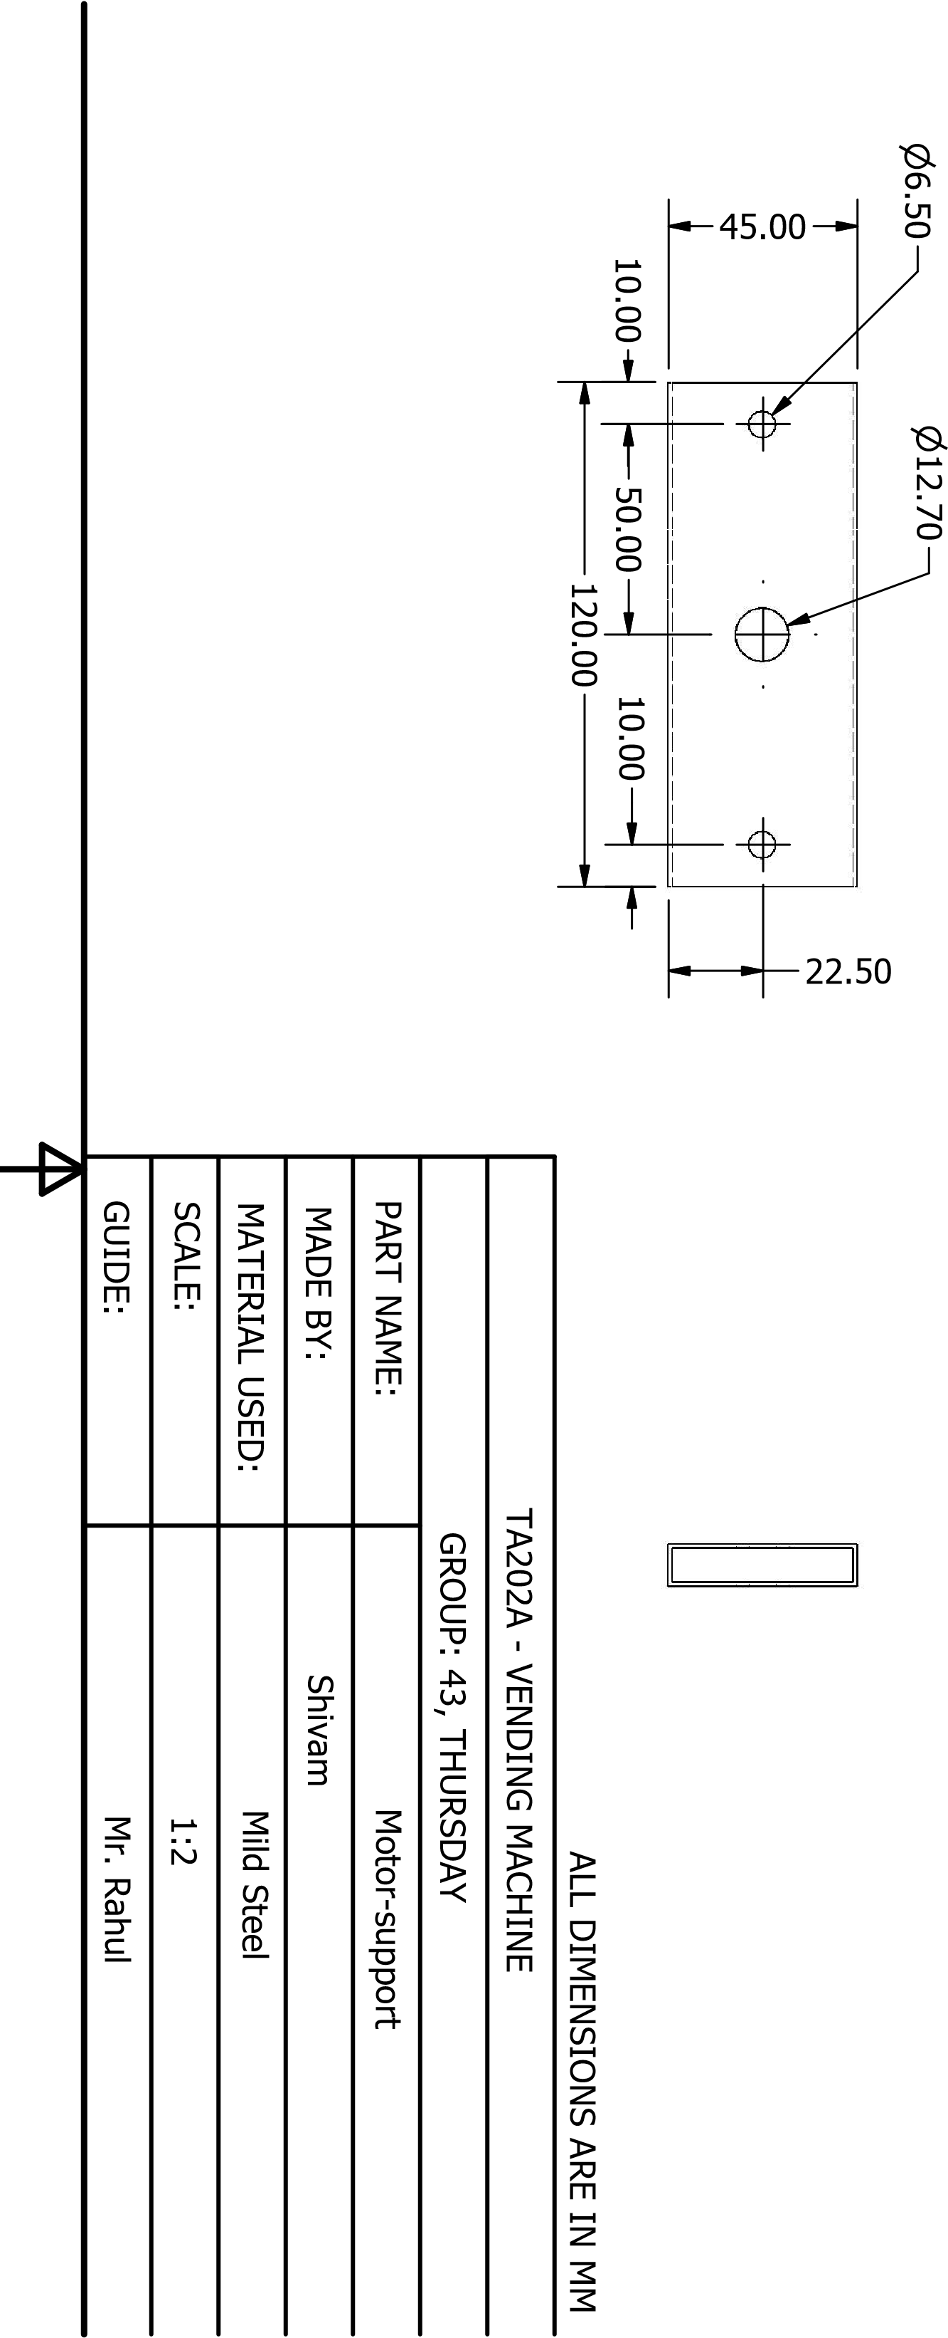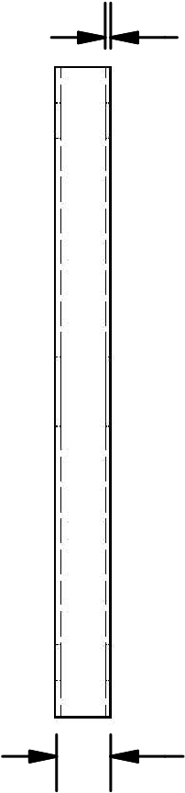1.00

10.00

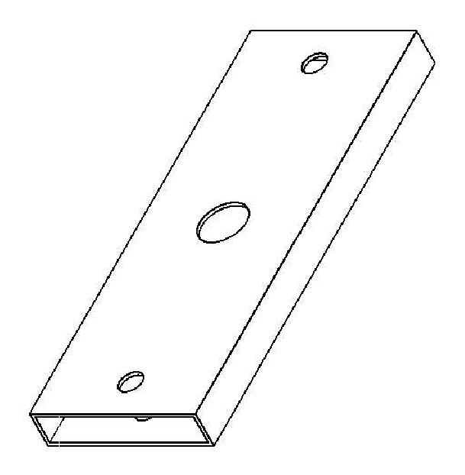

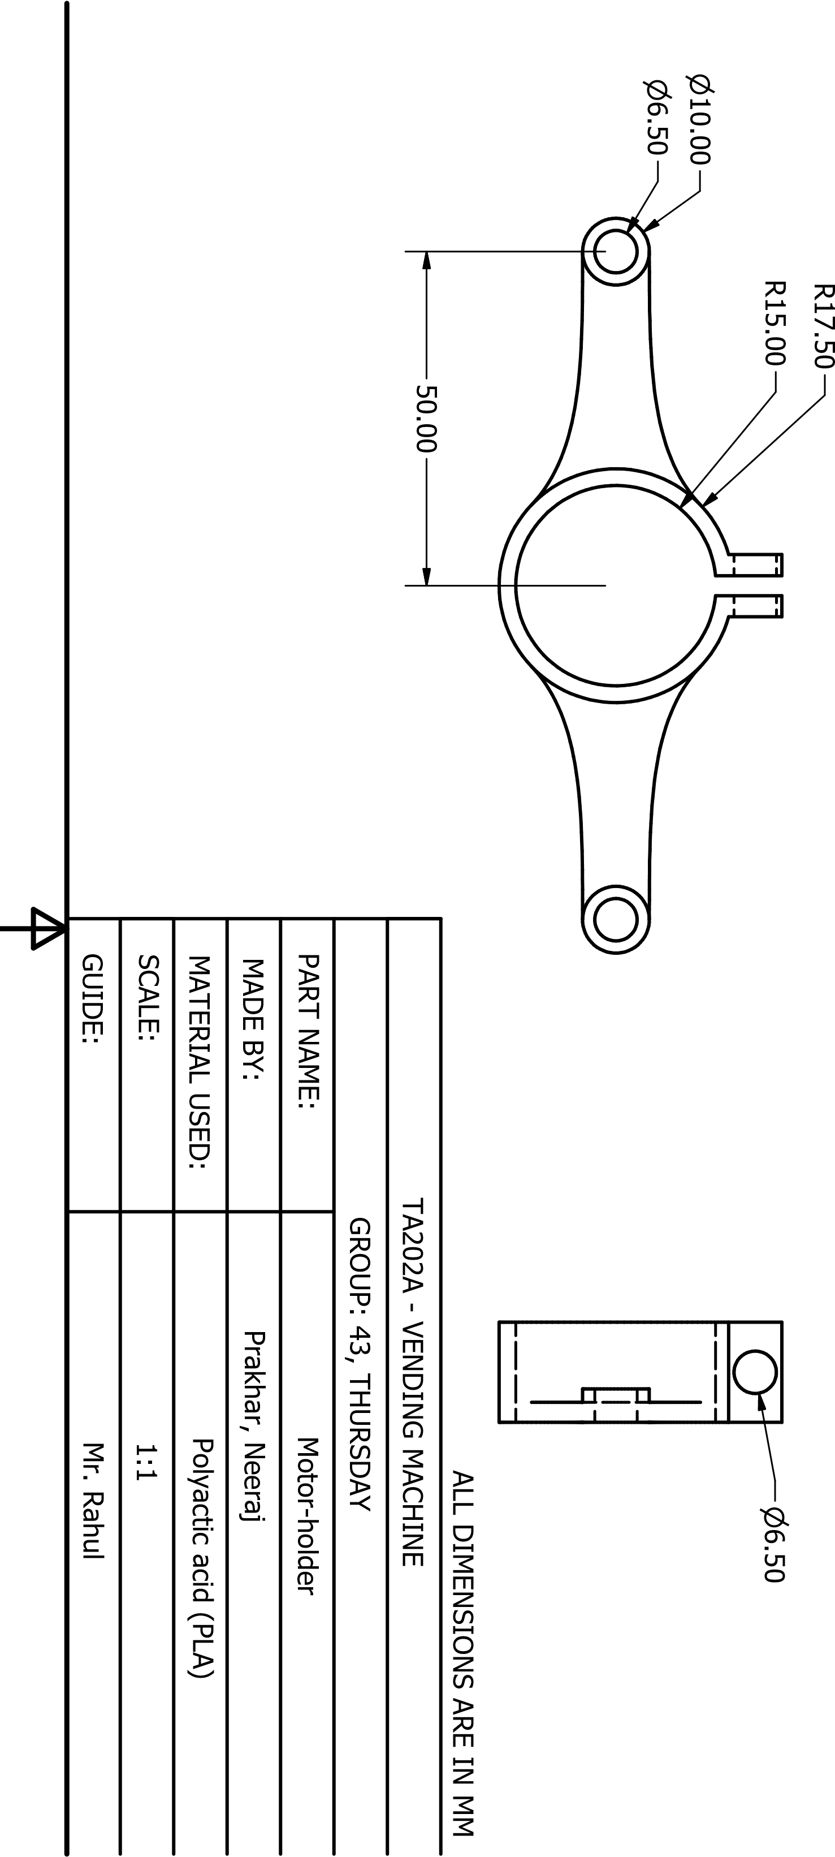

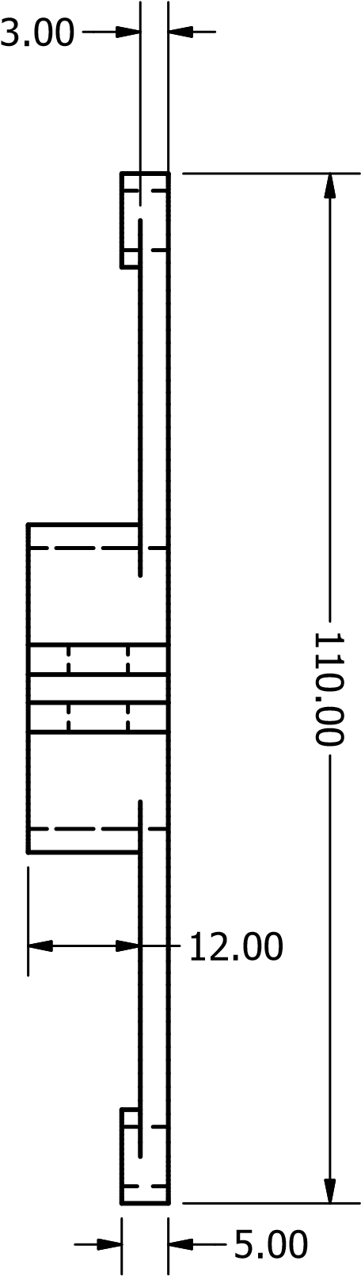

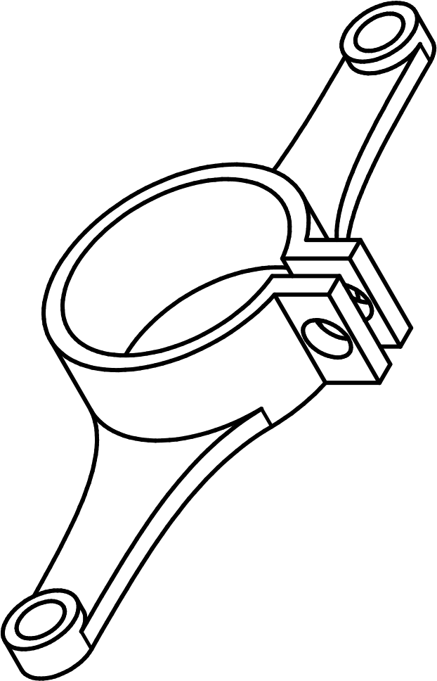

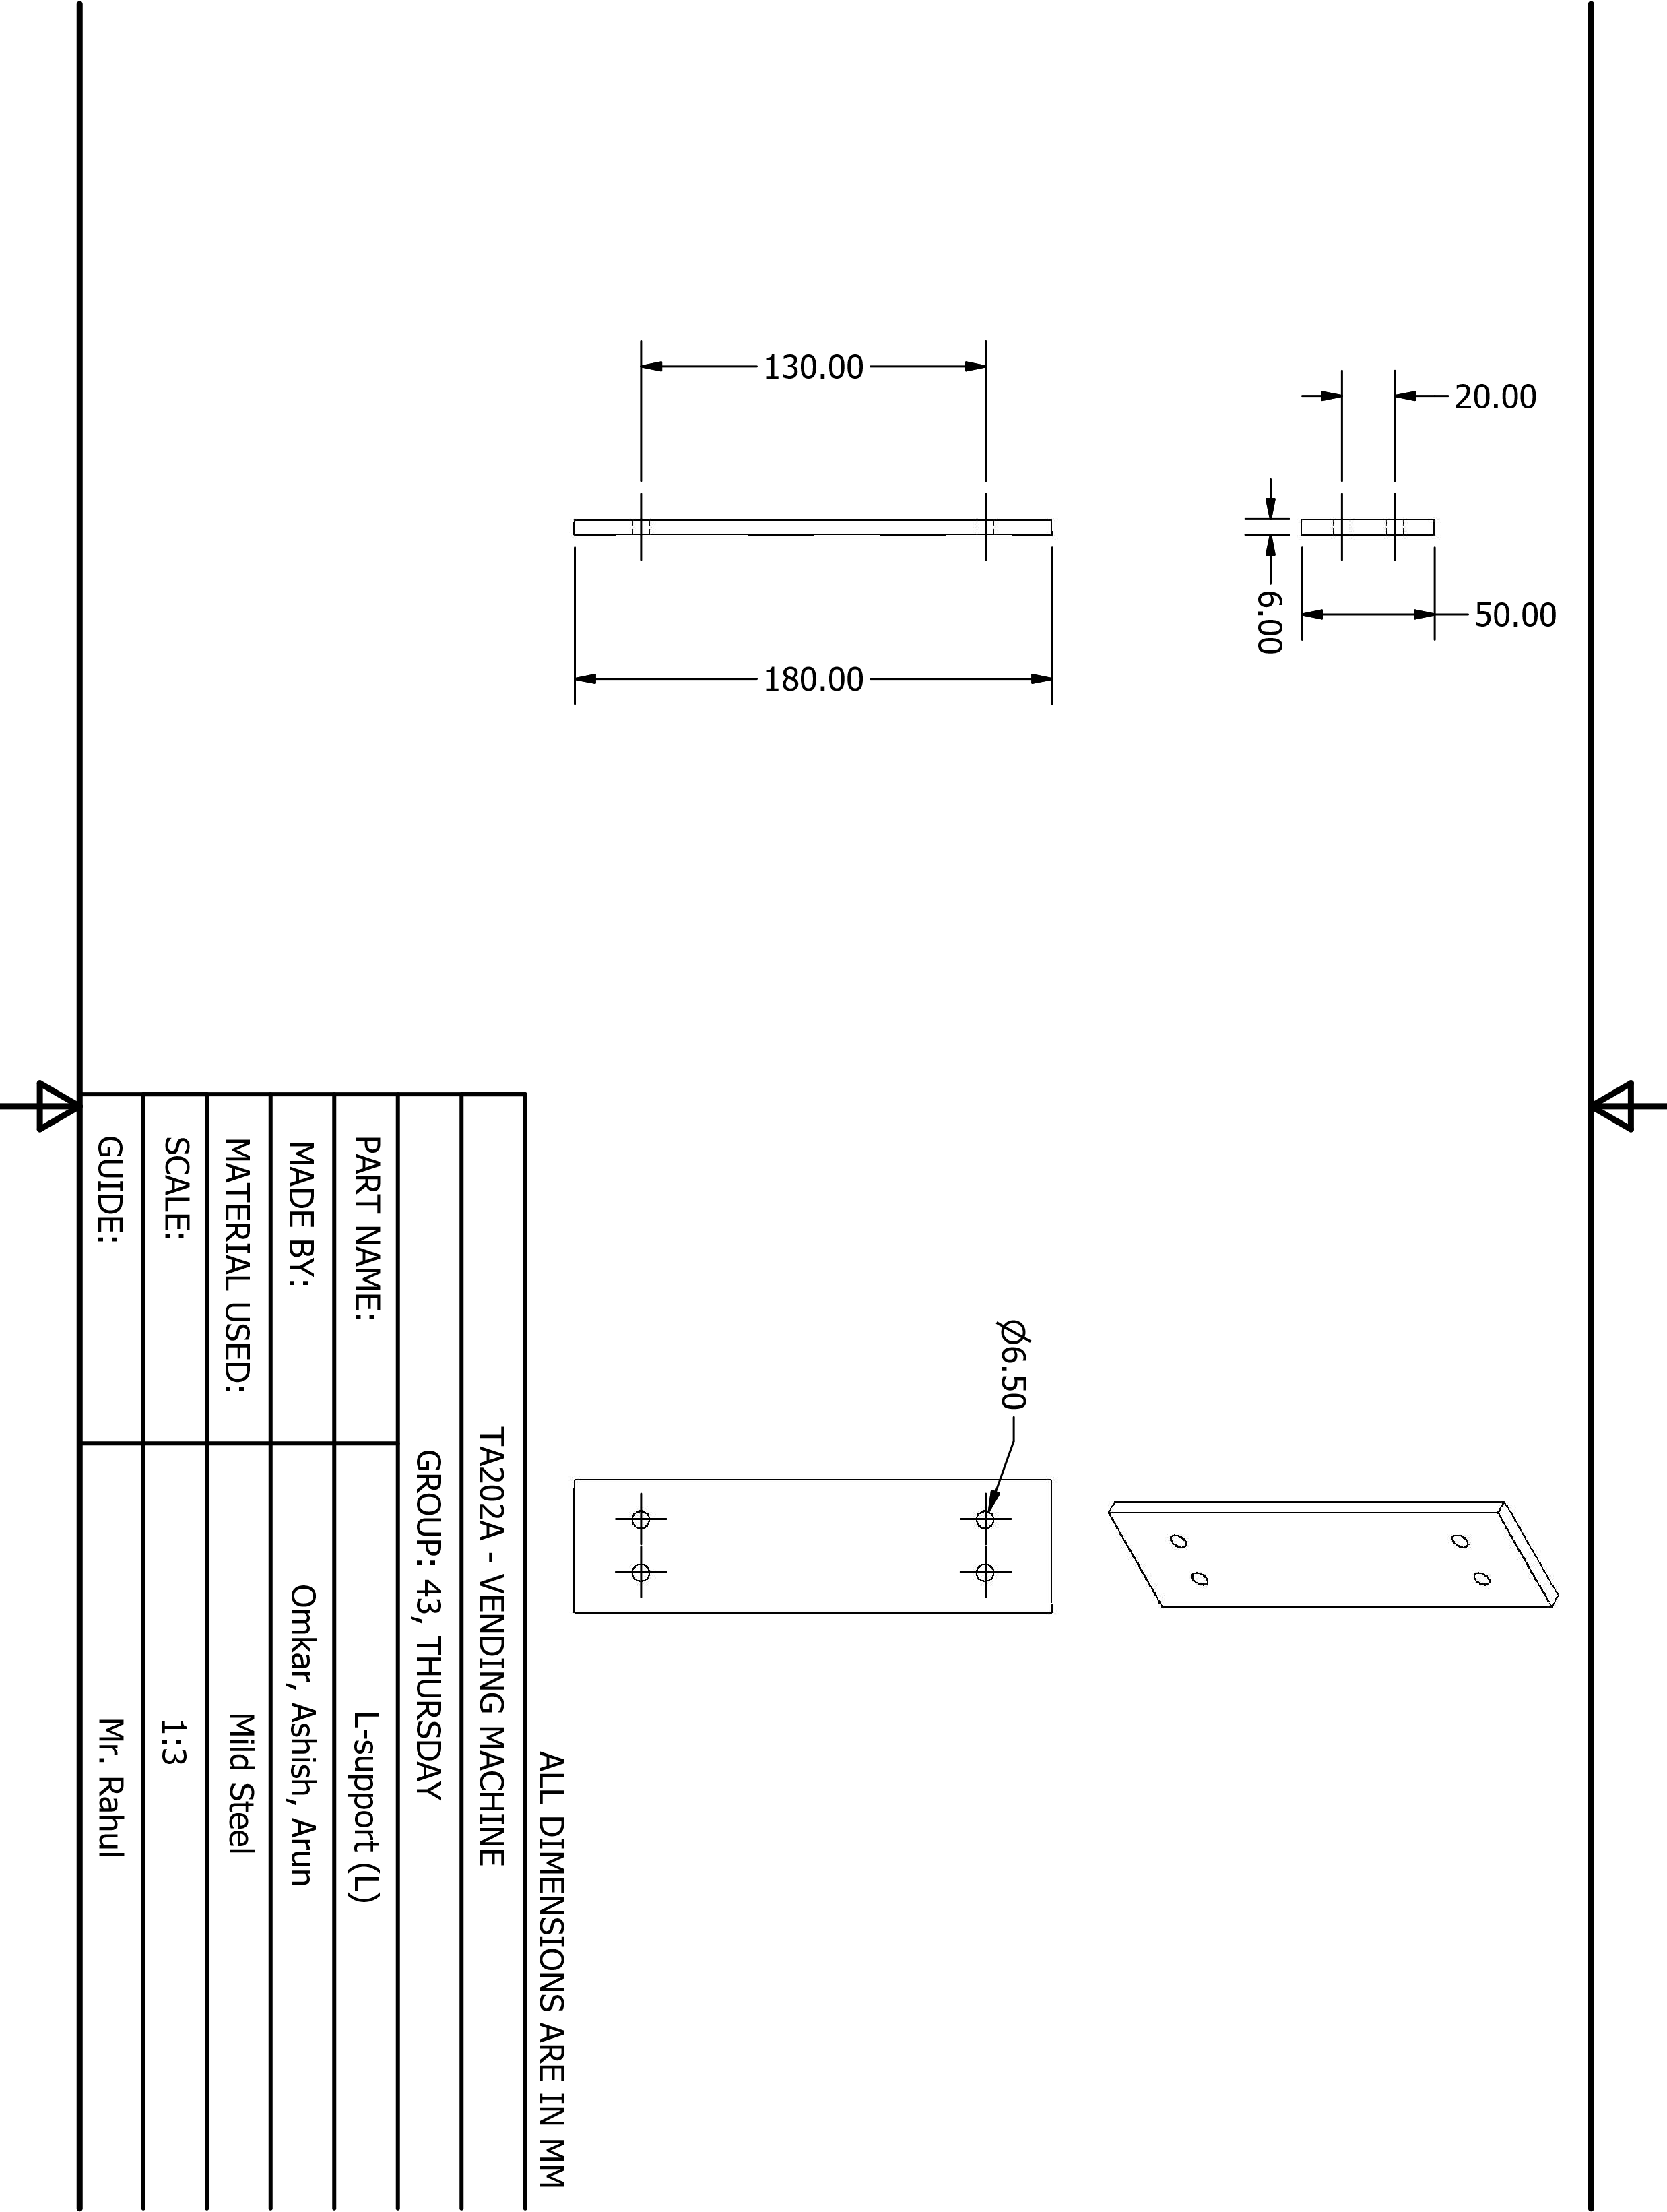

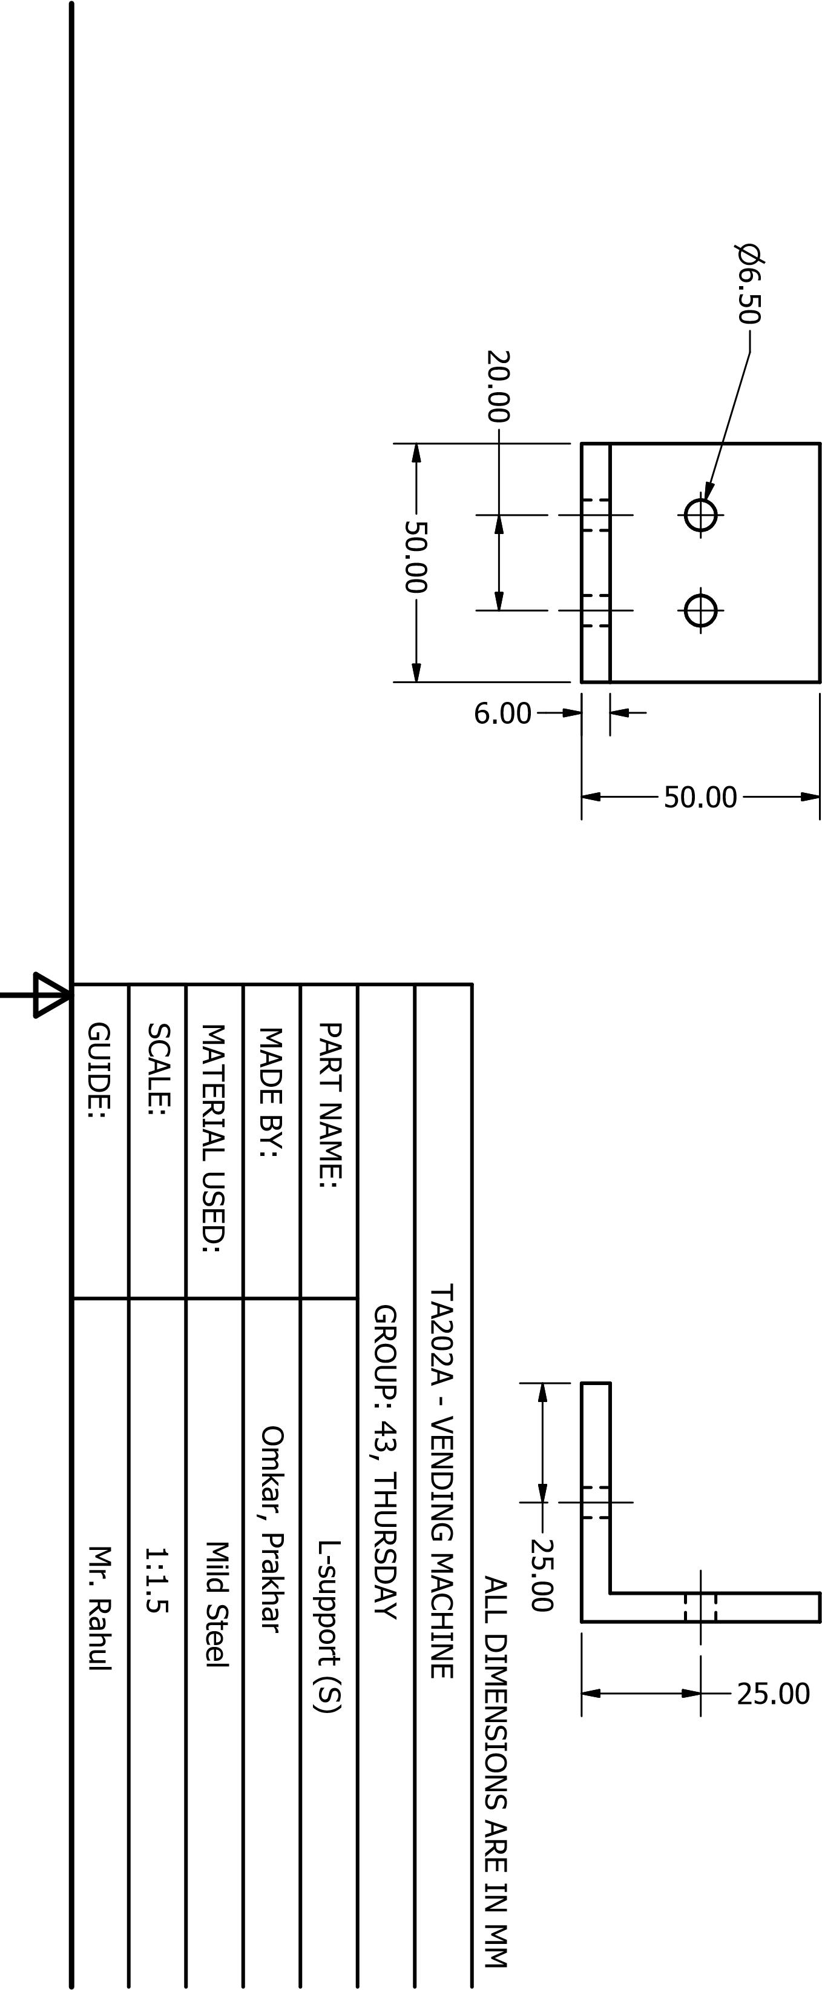

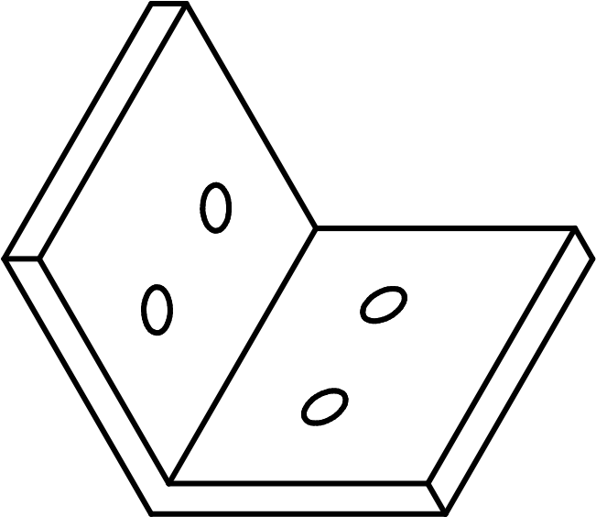

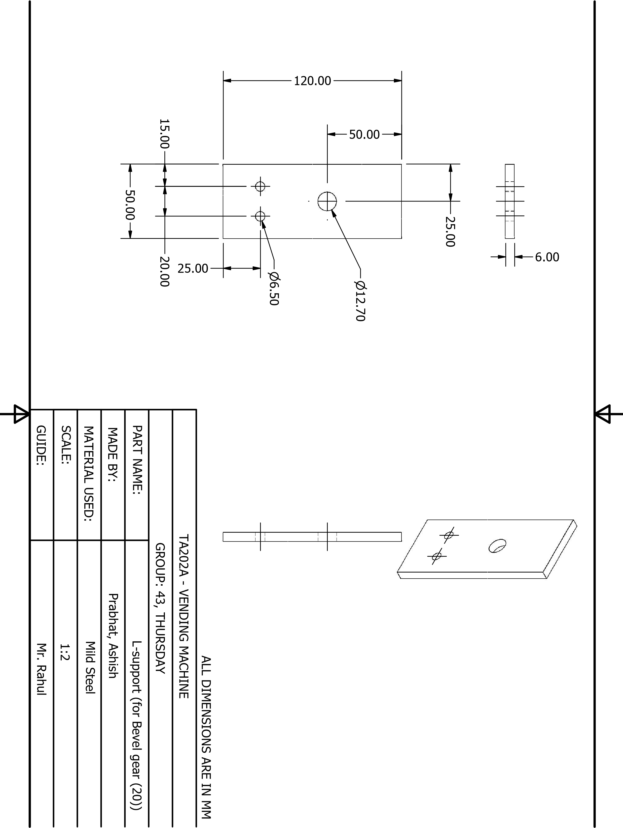

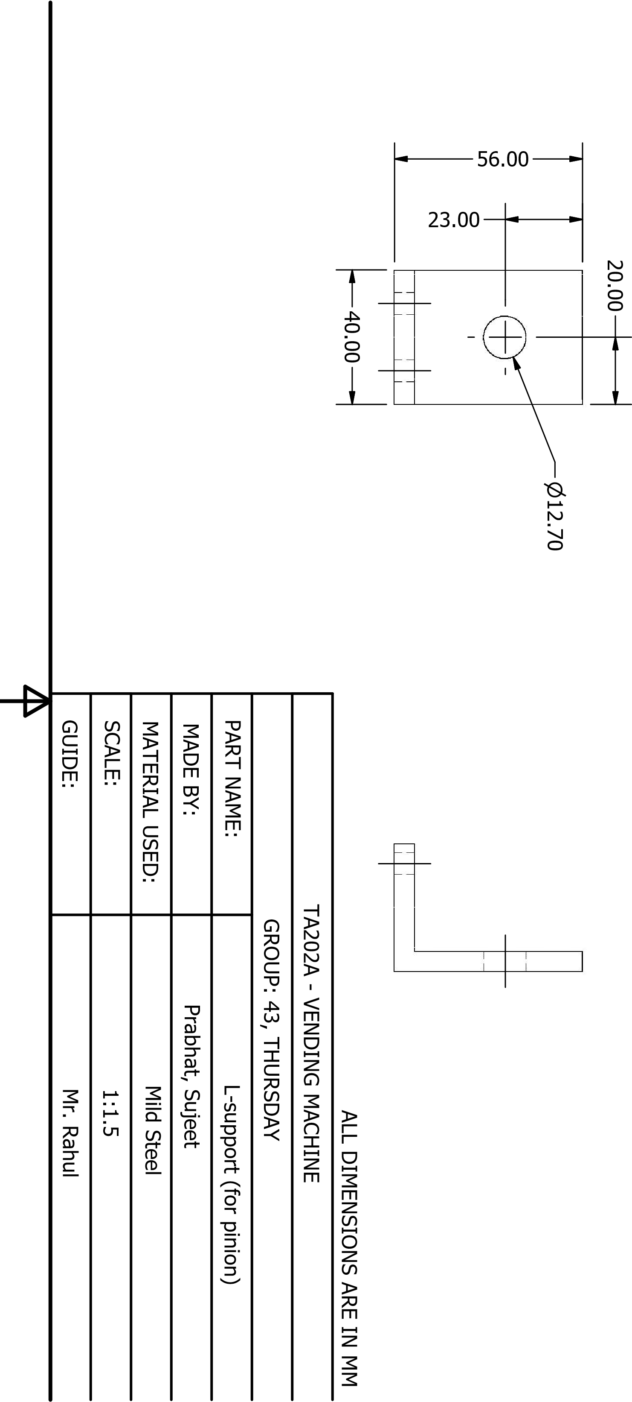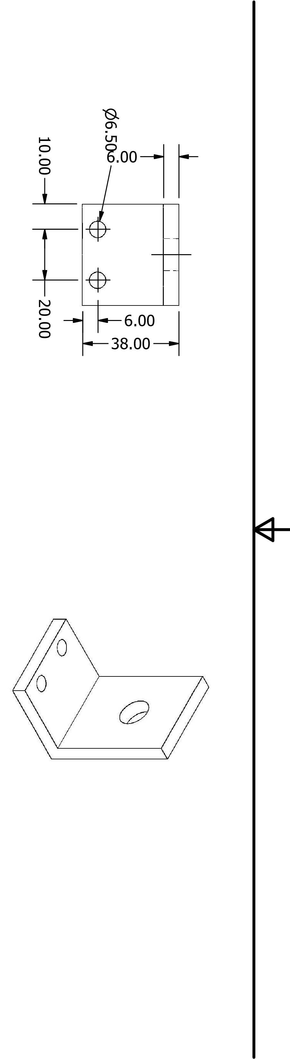

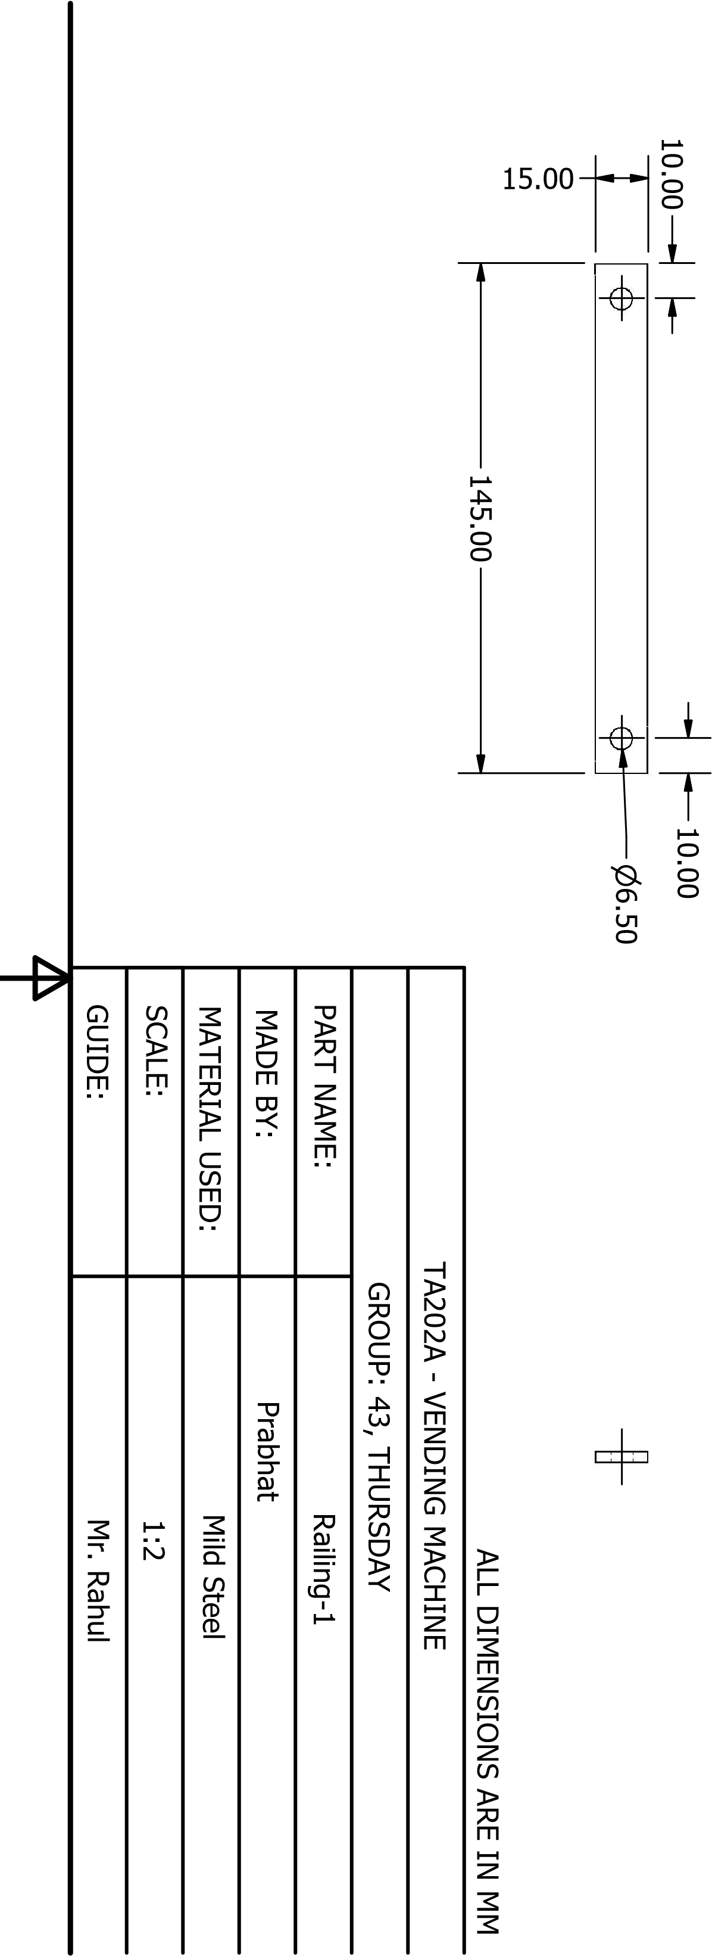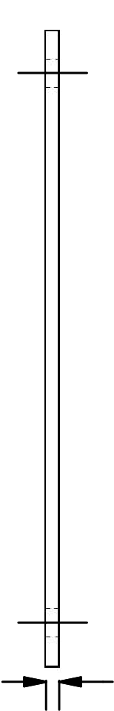3.00

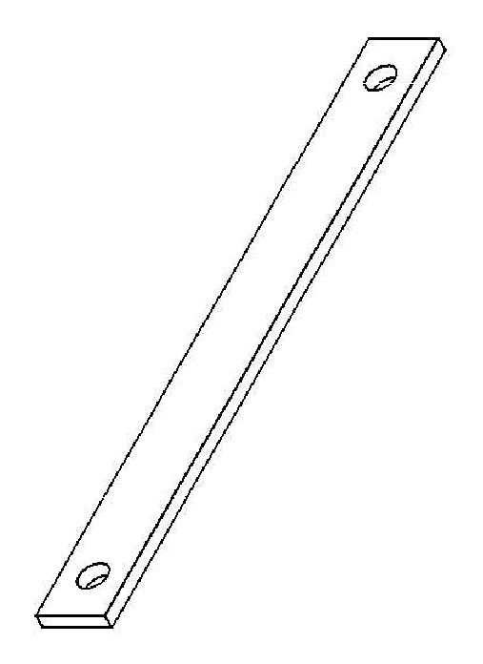

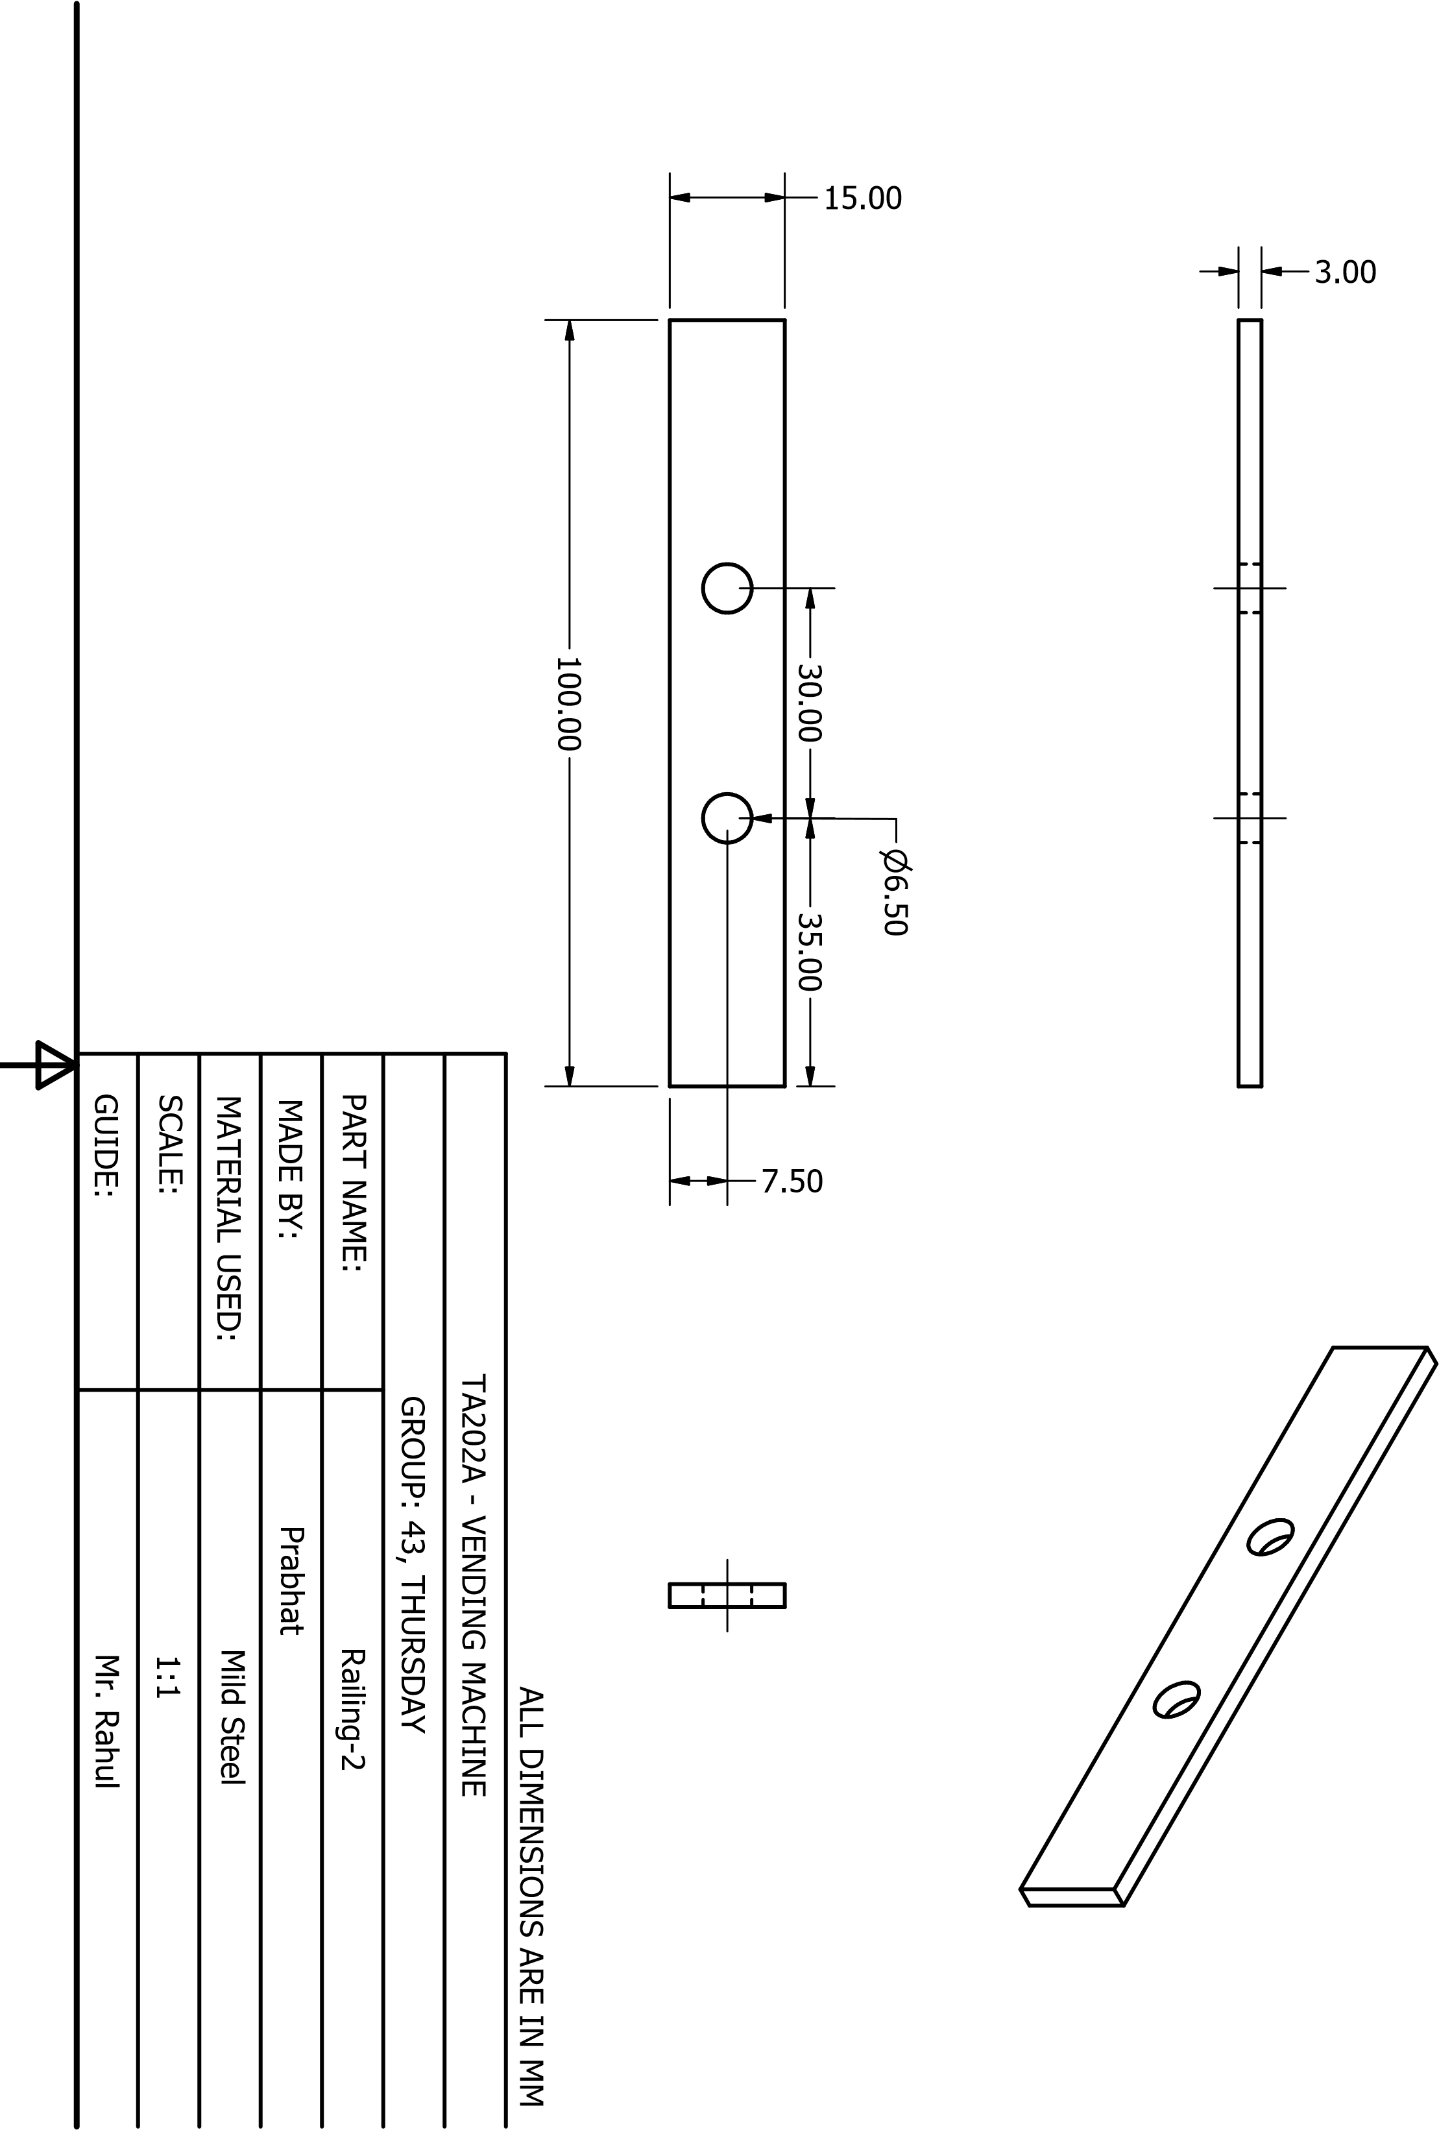

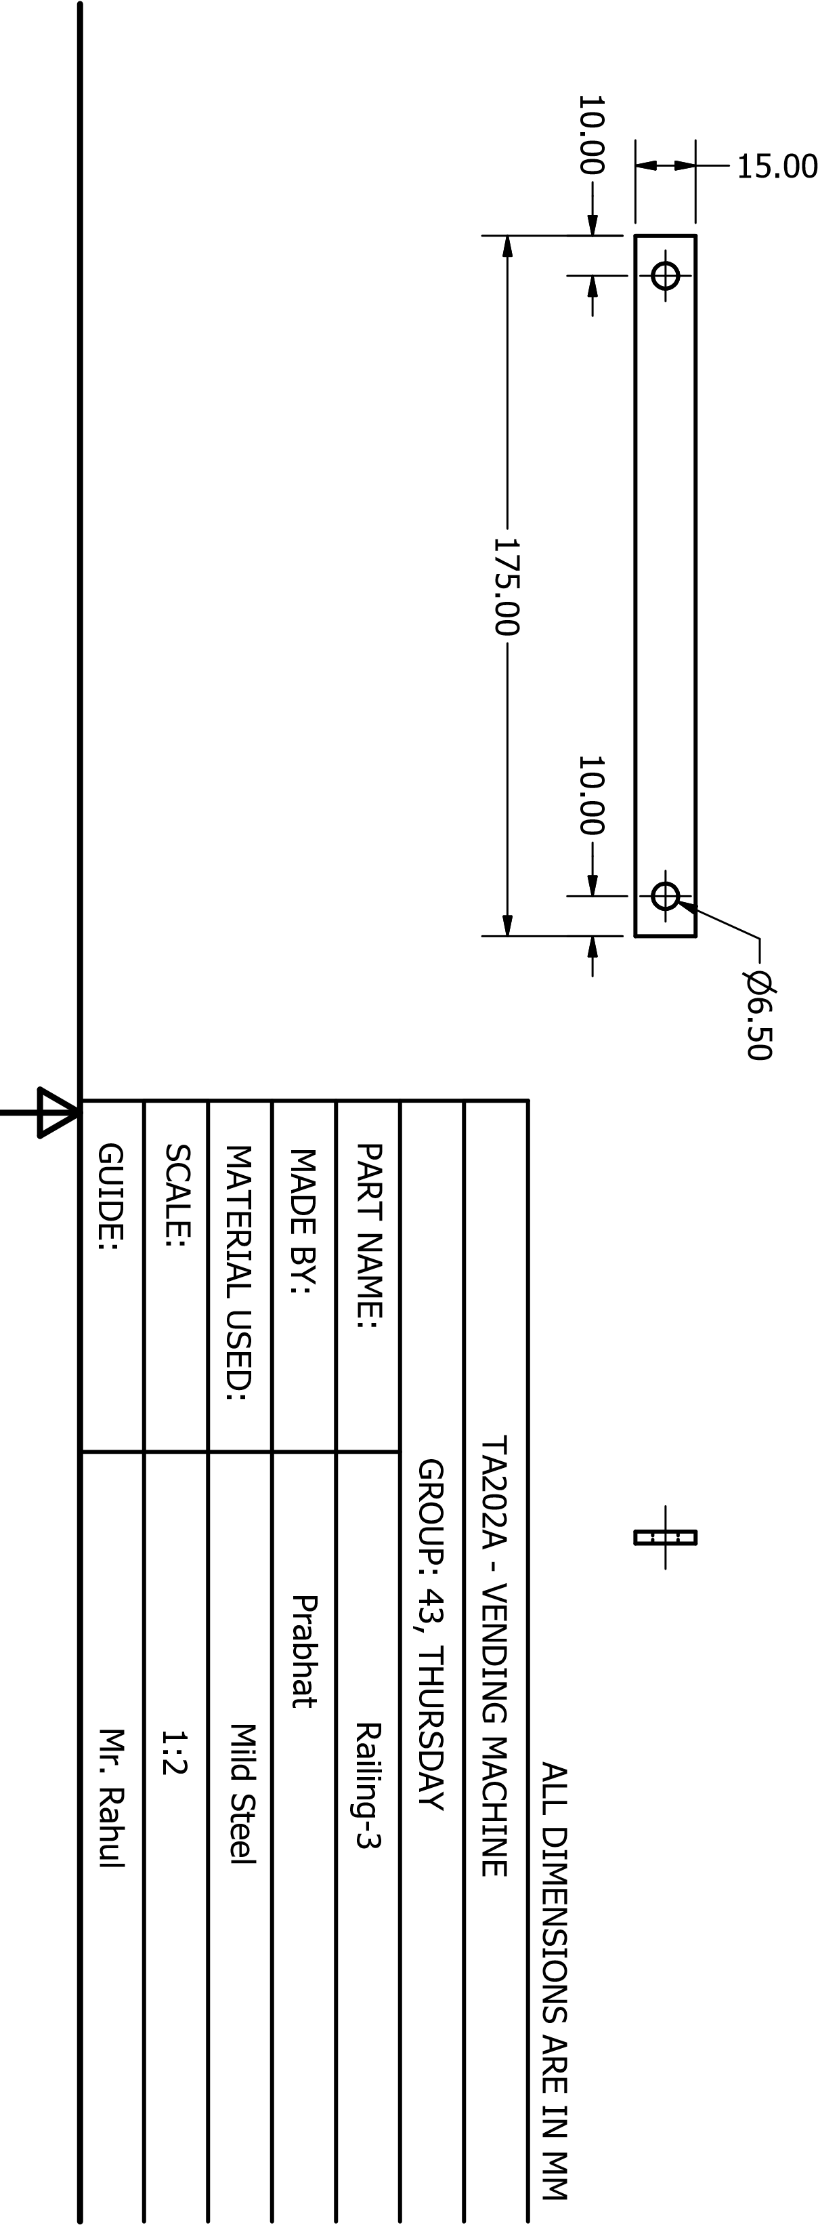3.00

# COST ANALYSIS

**Material Cost**

|  |  |  |  |
| --- | --- | --- | --- |
| Material | Quantity | Rate | Total price |
| Mild Steel | 25.032 kg | 100 Rs/Kg | 2503 Rs |
| Galvanized Iron | 300 gm | 75 Rs/Kg | 22.5 Rs |
| Motors | 1 Electric kit | 1000 Rs/Kit | 1000 Rs |

**Machining Cost**

|  |  |  |  |
| --- | --- | --- | --- |
| Process | Rate (Rs/hour) | Time (hours) | Total Price (Rs) |
| Milling | 250 | 5 | 1250 |
| Turning (Lathe) | 150 | 5 | 750 |
| 3D Printing | 100 | 2 | 200 |
| Drilling | 75 | 5 | 375 |

**Labor Cost**

|  |  |  |  |  |
| --- | --- | --- | --- | --- |
| Labor | Rate (Rs/8 hour) | Number of People | Time (hours) | Total Cost  (Rs/hour) |
| Unskilled | 650 | 7 | 18*7 | 10237.5 |
| Skilled | 850 | 5 | 15*5 | 7968.75 |

Total Labor Cost = 18,228.75 Rs

Total Project Cost = 24,306.75 Rs